Dichotomous Key Assignment /10

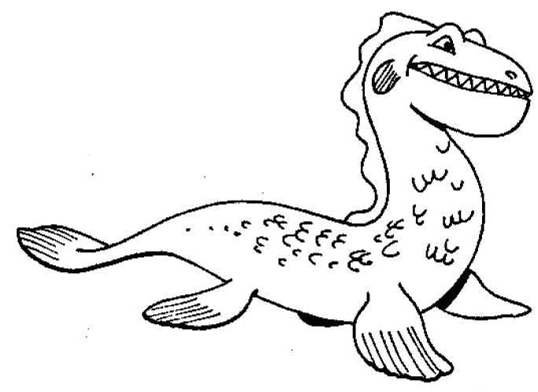READING A DICHOTOMOUS KEY (4 MARKS)

1. Key for a Fictitious Organism

1a. teeth (2)

1b. no teeth D. *cathius*

2a. horn D. *roikus*

2b. no horn *(4)*

3a. antennae D. *squattus*

3b. no antennae D. *unibodus*

4a. two eyes (5)

4b. more than two eyes D. *roostus*

5a. scales D. *failius*

5b. no scales *D. mythus*

6a. lips *D. hairius* Name of organism: \_\_\_\_\_\_\_\_\_\_\_\_\_\_\_\_\_\_\_\_\_\_\_

6b. no lips *D. malius*

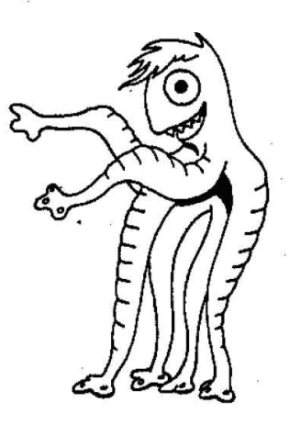

2. Key for multiple fictitious organisms

1a. horn ……………………………. (2)

1b. no horn………………………… T. *malkius*

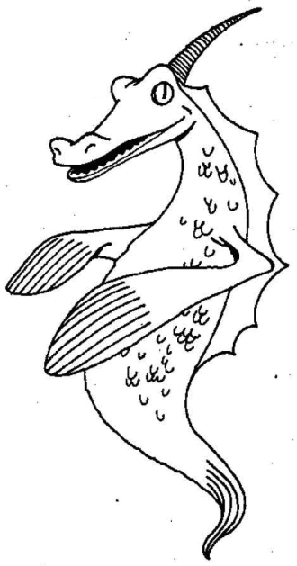2a. two eyes ………………………. (4)

2b. more than two eyes …………. H. *roikus*

3a. feet …………………………….. E. *squattus*

3b. no feet ………………………… D. *unibodus*

4a. tentacles ………………………. F. *athius*

4b. no tentacles ………………….. (5)

5a. fur …………………………….. D. *failius*

5b. no fur ………………………… (7)

6a. fingers ……………………….. *D. hairius*

6b. no fingers …………………… *D. malius*

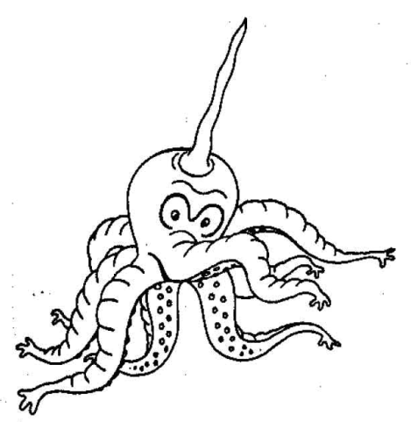7a. scales ………………………… H. *zilius*

7b. no scales …………………….. (8)

8a. lips …………………………… L. *falius*

8b. no lips ………………………. W. *canibus*

CREATE A DICHOTOMOUS KEY (6 MARKS)

Create a dichotomous key (not flow chart) that could be used to identify the following organisms:

*frog, shark, ladybug, bird, cat, octopus*.

j0280458j0358157j0398569j0346925j0232666an00470_

1a. \_\_\_\_\_\_\_\_\_\_\_\_\_\_\_\_\_……………………… \_\_\_\_\_\_\_\_\_\_\_\_\_\_\_\_\_\_\_

1b.