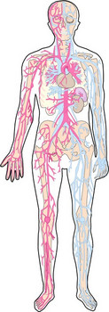
BODY CUT-OUT ASSIGNMENT
Working in partners, you will be making a body cut out of all the different systems in the human body covered in class.
- For each structure, be sure to include a detailed description of its function on a separate piece of paper.
- Include relationships between structures and its role in the body.
- Effort marks be creative and put some effort into your project

DIGESTIVE SYSTEM (35 Marks)
- Mouth
- Pharynx
- Nasopharynx
- Larynx
- Epiglottis
- Trachea
- Esophagus
- Stomach
- Small Intestine
- Pancreas
- Liver
- Gall Bladder
- Large Intestine
- Rectum
- Anus

CIRCULATORY SYSTEM (16 marks)
- Heart
- Left/Right Atria
- Left/Right Ventricles
- valves (4 total)
- aorta
- pulmonary arteries/veins

RESPIRATORY SYSTEM
(14 marks)
- trachea
- lungs
- bronchi
- bronchioles
- alveoli
- diaphragm

LYMPHATIC SYSTEM
(35 marks)
- pathogen
(show an infection somewhere on your body cut-out)
First line of Defense
- skin
- sweat glands
- oil glands
- gastric juices
- mucus
- cilia
Second Line of Immune Defense
(Innate Immune Response)
- Inflammation
- Phagocytes
(Acquired Immune Response)
- Antigen
- B cells
- Antibodies
- T cells (helper/killer)

TOTAL: _______/100 marks

