Microscopes: Calculating Magnification
1. Calculate the missing values in the table below:

Power | Field of View  (FOV) | Ocular lens magnification | Objective lens magnification | Total Magnification
LOW | 4.5 mm | 10x |  | 40 x
MEDIUM | 2 mm | 10x | 10 x
HIGH | 0.5 mm | 10x |  | 400 x

METRIC CONVERSIONS
2. Since microscope magnifications are very small, we will often use micrometers (µm). Convert the following:
1000 µm = 1 mm 10,000 µm = 1 cm 1,000,000 µm = 1 m

Ex. 5 mm = ______ µm

- 3.3 mm = ________ µm
- 0.78 mm = _______ µm
- 390 µm = ________ mm
- 4600 µm = _______ mm

ACTUAL SIZE

Find the actual size of each of the following:
- 18 cells fit across high power

- 10 cells fit across medium power

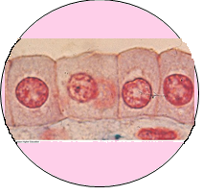
40 X

MAGNIFICATION
- If the actual size of an amoeba is 46 µm, calculate the drawing’s magnification
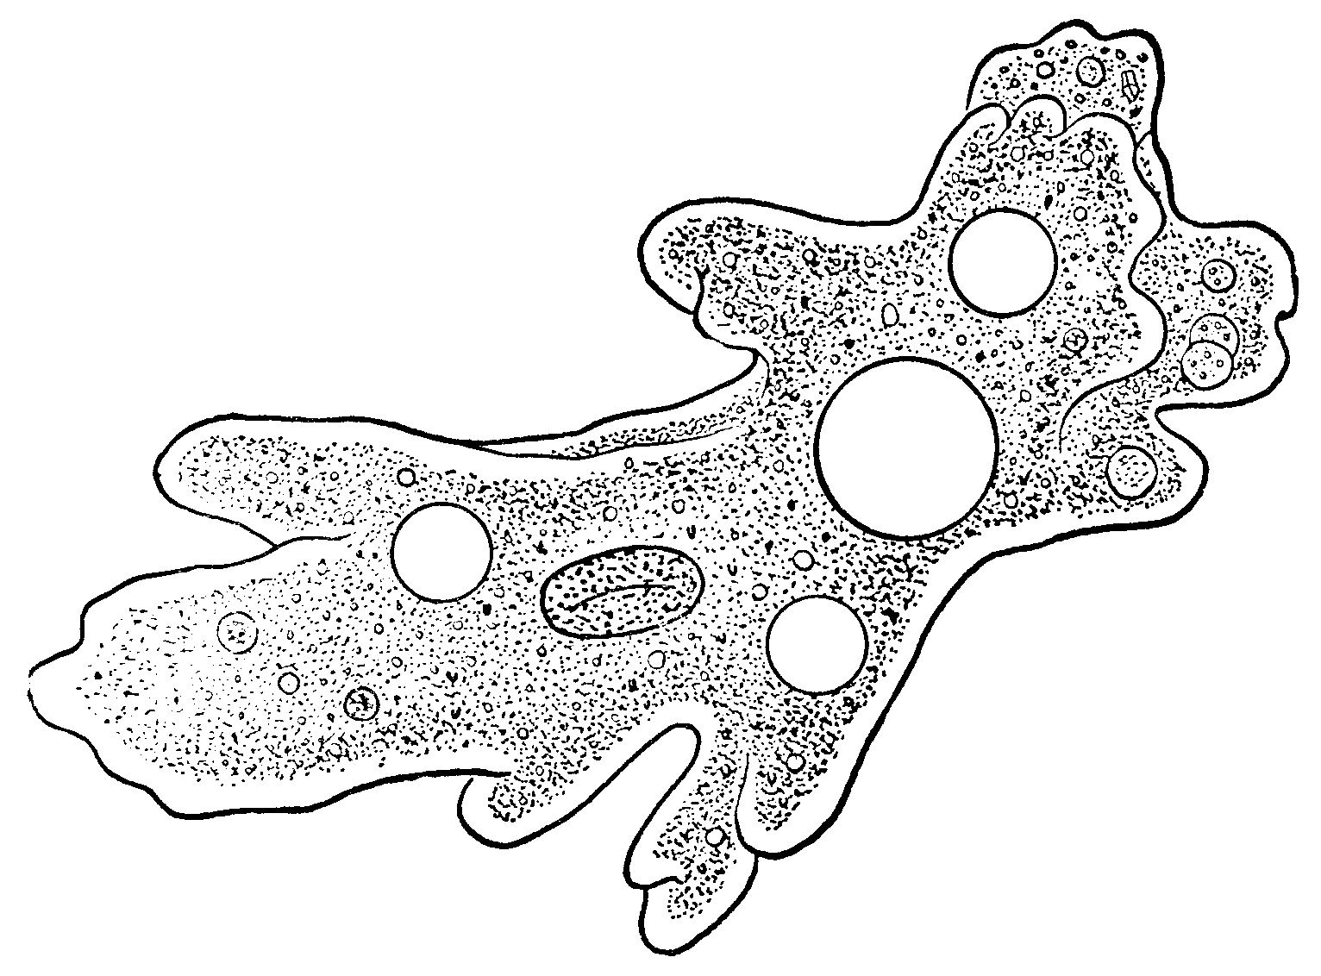

- If the drawing size of the Euglena is 24 mm, and the actual size is 83 µm, calculate the drawing’s magnification

- If you are looking at a paramecium at MEDIUM power and you measured it to be 0.3 mm, and your drawing size is 2.5 cm, calculate your drawing’s magnification.

