Riding the Waves
INSTRUCTIONS
Complete the exercises on this page. You may refer to pages 135 and 136 of BC Science 8 if you need to review.

1. In the diagram below, fill in the labels on the right side of the picture. Choose words from this list: trough, amplitude, crest, wavelength, rest position.

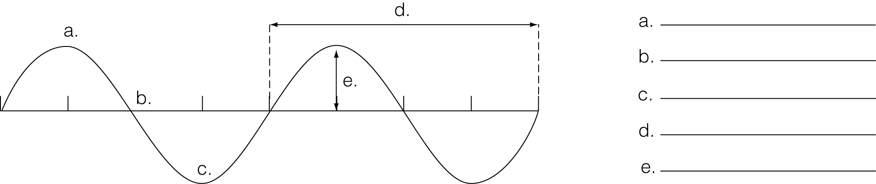

2. How many wavelengths are shown in the above diagram?_______________

3. The number of cycles per second is the _______________, which is measured in _______________ (Hz).

4. Calculate the frequency of a wave that goes up and down 8 times in 4 seconds.
______________________________________________________________________________

5. In the diagram below, how many wavelengths apart are the two ducks? __________________

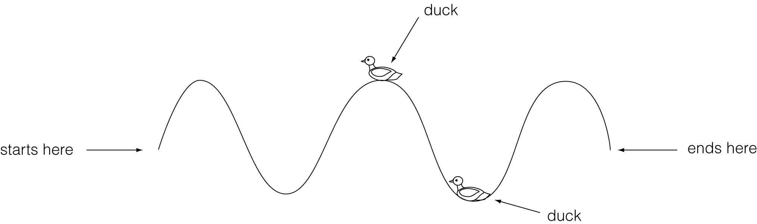

6. In the above diagram, how many wavelengths are shown? _______________

ALL ABOUT WAVES
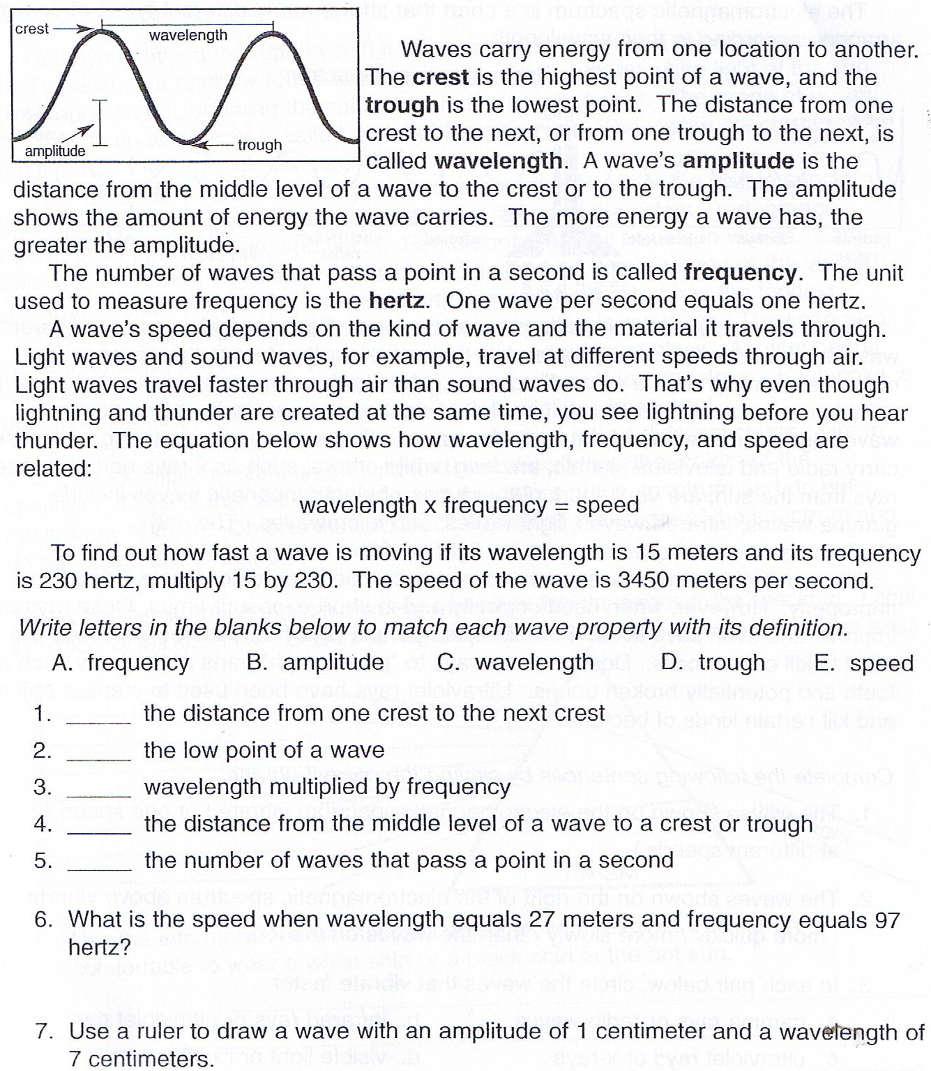

An Energy Chart
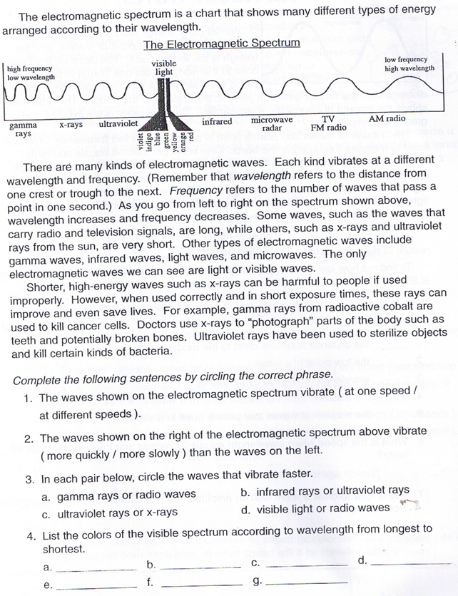

ROY G BIV
INSTRUCTIONS
Determine the wavelengths of the colours of the spectrum. Fill in the colors of the spectrum in the diagram below. For help, refer to the chart on page 146 of BC Science 8.

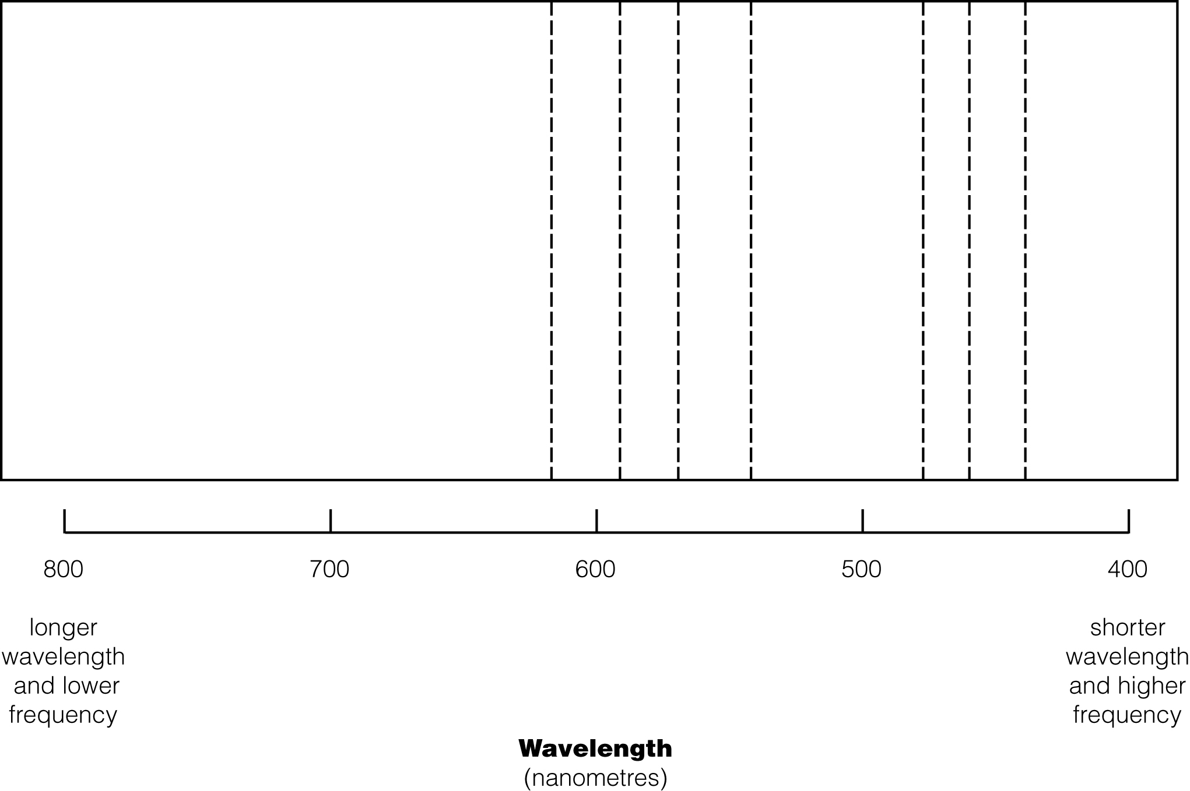

Answer Key

Riding the wave:
1. (a) crest (b) rest position (c) trough (d) wavelength (e)amplitude
2. Two wavelengths are shown.
3. Frequency; hertz
4. 8 cycles in 4 seconds makes a frequency of 2 Hz.
5. Ducks are half a wavelength apart.
6. Two and a half wavelengths are shown.

All about Waves
1. C
2. D
3. E
4. A
5. B
6. 27 x 97= 2619hz
7.

Energy Chart
- Different speeds
- More slowly
- a. gamma
b. UV
c. x-ray
d. visible light
- red, orange, yellow, green, blue, indigo, violet

Roy G BIV
Answers should reflect Figure 4.12 on page 146 of the student book.

