Parts of a Microscope
Identify the labeled parts of the microscope below. Refer to page 499 in BC Science 8 if you need help.

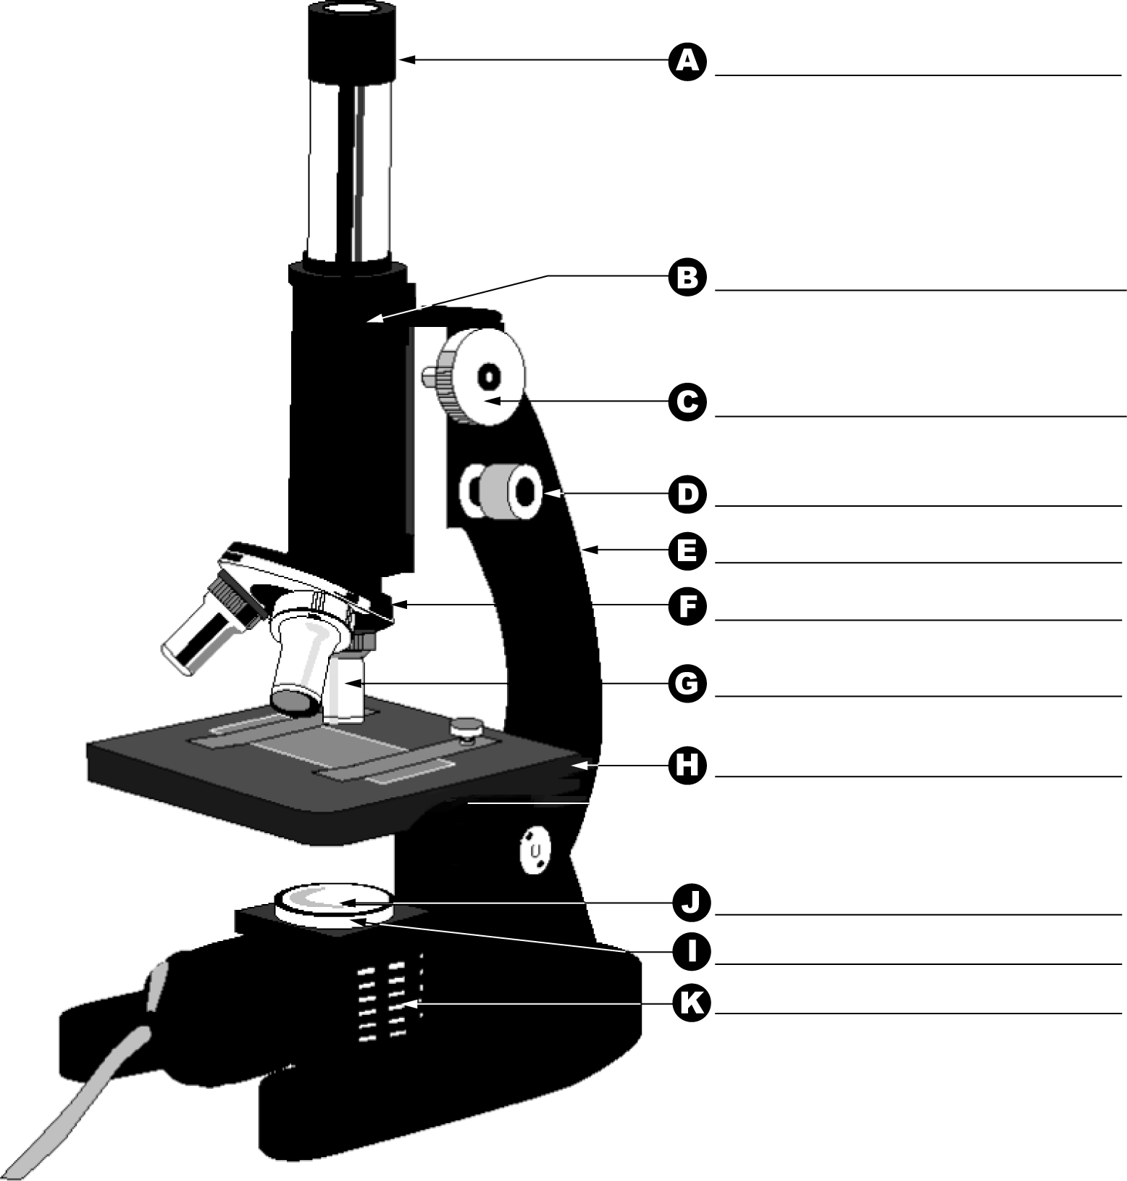

 | WORD | DEFINITION
A
B
C
D
E
F
G
H
I
J
K

ANSWER KEY

Microscope part | Function
Eyepiece | The part you look through. It has a lens that magnifies the object, usually by 10×.
Tube | Holds the eyepiece and the objective lenses at the proper working distance from each other.
Revolving nosepiece | Rotating disk that holds two or more objective lenses. Turn it to change lenses. Each lens clicks into place.
Objective lenses | Magnify the object. Different lenses provide different levels of magnification.
Fine focus knob | Use with medium- and high-power magnification to bring the object into sharper focus.
Coarse focus knob | Moves the tube or stage up or down to bring the object into focus. Use it only with the low-power objective lens.
Stage | Supports the microscope slide. Clips hold the slide in position. A hole in the centre of the stage allows the light from the light source to pass through the slide.
Base | Directs light to the object being viewed.
Light source | Lights the object being viewed.

