Periodic Table Scavenger Hunt

Use your periodic table to answer the following questions.

1. Identify each element.

(a) The element in group 5 and period 5 ____________________________________________

(b) Only halogen that is a liquid at room temperature and pressure ______________________

(c) Alkali metal with the most massive atoms _________________________________________

(d) Synthetic element in period 5 ___________________________________________________

(e) Metal in group 16 and period 4 _________________________________________________

(f) Alkaline earth element with the least massive atoms ________________________________

(g) Noble gas that has atoms with 54 protons _________________________________________

2. Complete the following table. The first row is completed as an example.

|  |  |  |  |
| --- | --- | --- | --- |
| Name of Element | Atomic Number | Number of Protons | Number of Electrons |
| silicon | 14 | 14 | 14 |
|  | 8 |  |  |
| chromium |  |  |  |
| sodium |  |  |  |
|  |  | 13 |  |
|  |  |  | 19 |

3. Shade in the following chemical families, as indicated, on the outline of the periodic table.

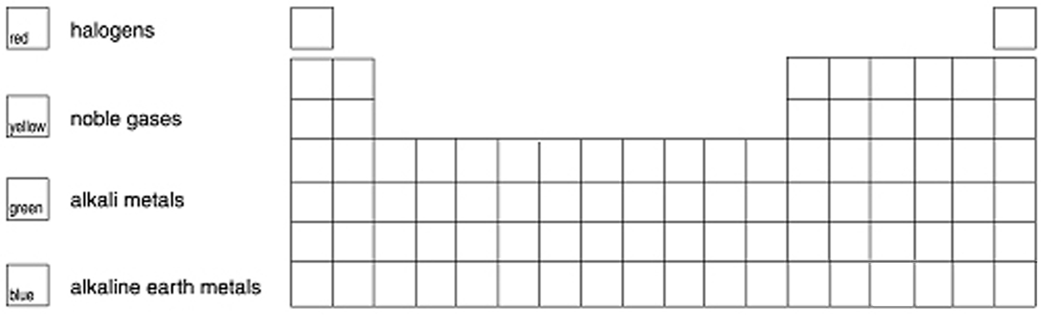

ANSWER KEY

BLM 2-8, Periodic Table Scavenger Hunt

1. (a) niobium, Nb

(b) bromine, Br

(c) francium, Fr

(d) technetium, Tc

(e) tellurium, Te

(f) beryllium, Be

(g) xenon, Xe

2. Answers are in boldface.

|  |  |  |  |
| --- | --- | --- | --- |
| Name of Element | Atomic Number | Number of Protons | Number of Electrons |
| silicon | 14 | 14 | 14 |
| oxygen | 8 | 8 | 8 |
| chromium | 24 | 24 | 24 |
| sodium | 11 | 11 | 11 |
| aluminum | 13 | 13 | 13 |
| potassium | 19 | 19 | 19 |

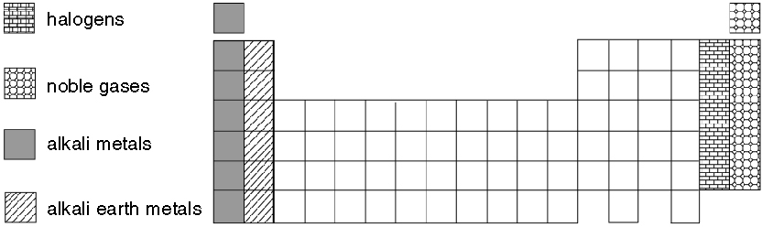3.