Reflection: Ray Diagrams
INSTRUCTIONS
1. Label the diagram below using the following terms: reflected ray, normal, angle of reflection, angle of incidence, and incident ray.

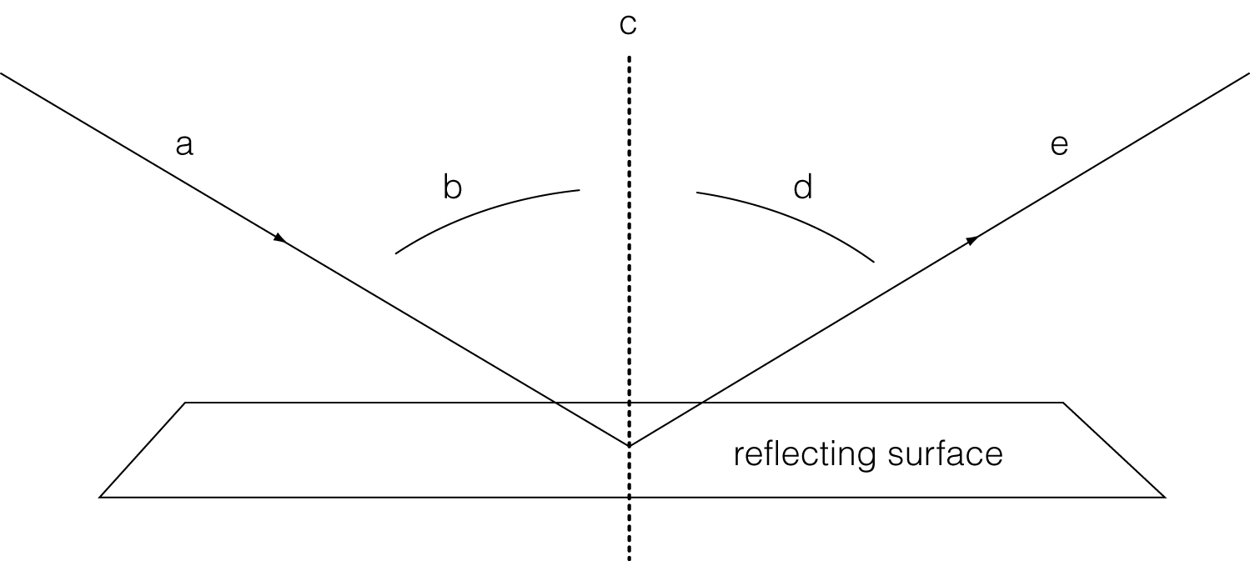

(a) ___________________________________________________________
(b) ___________________________________________________________
(c) ___________________________________________________________
(d) ___________________________________________________________
(e) ___________________________________________________________

2. Measure the two angles with your protractor.
Angle of incidence = __________ Angle of reflection = __________

3. Compare the sizes of the angles of incidence and reflection.
______________________________________________________________
______________________________________________________________

Continued on next page
4. Use the law of reflection to draw the path of the reflected ray from the mirror in the diagram below.

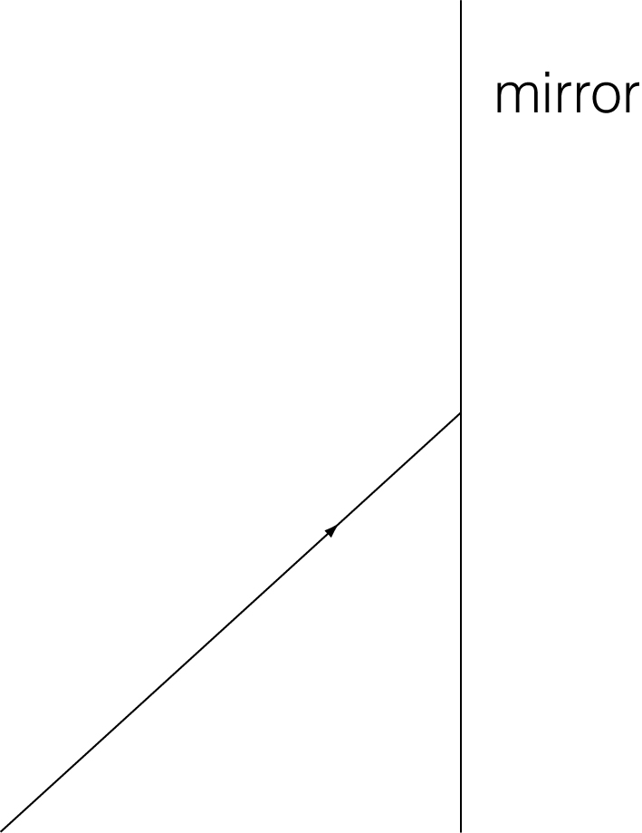

5. The diagram below shows a light ray coming through an opening and directed at two mirrors and three flowers. Use the law of reflection, your ruler, and your protractor to draw the light ray as it bounces from one mirror to the next.

