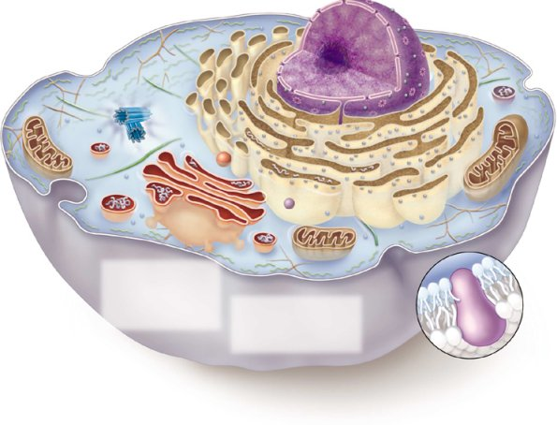
7-2 Eukaryotic Cell Structure
Define the following structures using your textbook pg. 174 – 183.

ORGANELLES
Organelle= “little organ”
Found only inside eukaryotic cells
All the stuff in between the organelles is cytosol
Area between the nucleus and the cell membrane is the cytoplasm

CELL MEMBRANE
Selective barrier controlling what goes in and out of cells
Selectively permeable – only allows certain items through
Made of a phospholipid bilayer with proteins embedded in it

NUCLEUS
“brain of the cell”: Control center contains DNA
Surrounded by a double membrane
Usually one per cell

NUCLEAR MEMBRANE
A double membrane that surrounds the nucleus
Contains many small pores to allow molecules to pass through

NUCLEOLUS
Within the nucleus
Produces ribosomes (which manufacture proteins)

CHROMOSOMES
Large structures of protein and DNA that contain genetic information

ENDOPLASMIC RETICULUM (ER)
Connected to nuclear membrane
Highway of the cell: transport system

Rough ER: studded with ribosomes; it makes proteins

Smooth ER: no ribosomes; it makes lipids

RIBOSOME
Site of protein synthesis
Found attached to rough ER or floating free in cytosol
Produced in nucleolus
GOLGI APPARATUS
Looks like a stack of plates
Stores, modifies and packages proteins
Molecules transported to and from the Golgi by means of vesicles

LYSOSOMES
“trash collectors”
Contain digestive enzymes that break down wastes
Formed by golgi

MITOCHONDRIA
“Powerhouse of the cell” = produces energy (ATP)
Site of Cellular respiration
Sugar + oxygen carbon dioxide + water + ATP
Bound by a double membrane
Has its own strand of DNA

CYTOSKELETON
Acts as skeleton and muscle
Provides shape and structure to cell
Helps move organelles around the cell
Made of three types of filaments

CHLOROPLAST
Found only in plant cells
Contains the green pigment chlorophyll
Site of food (glucose) production
Bound by a double membrane

CELL WALL
Found in plant and bacterial cells
Rigid, protective barrier
Located outside of the cell membrane
Made of cellulose (fiber)

VACUOLE
Large central vacuole usually in plant cells
Many smaller vacuoles in animal cells = vesicle
Storage container for water, food, enzymes, wastes, pigments, etc.

CENTRIOLE
Aids in cell division
Usually found only in animal cells
Made of microtubules

