Mirror Images
INSTRUCTIONS
Use a mirror to read the three messages below. Then answer the following questions.

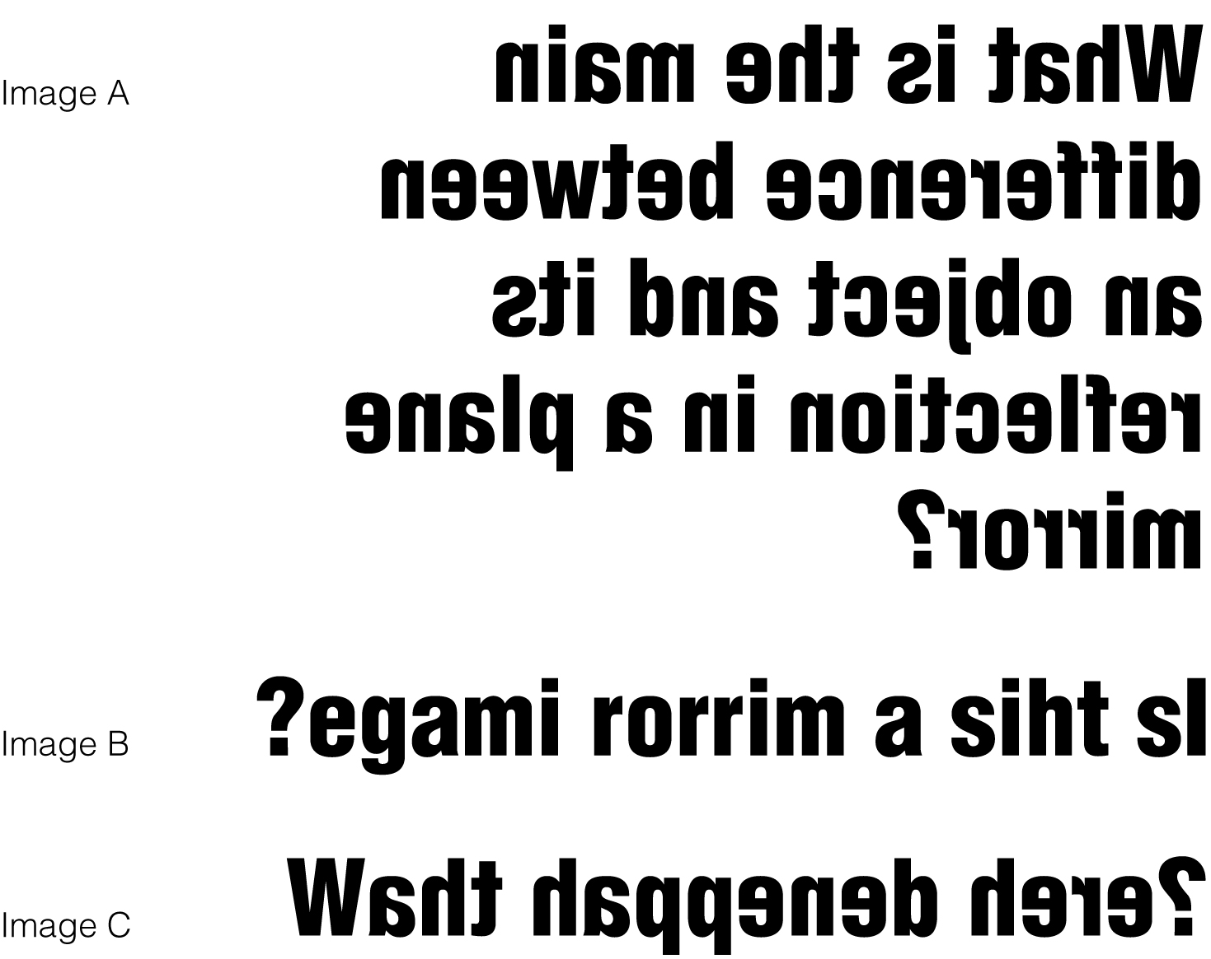

1. Which of these images is a true reflection in a plane mirror?
______________________________________________________________

2. How were the other images made?
______________________________________________________________
______________________________________________________________

3. Consider all of the letters of the alphabet. What capital letters look the same when they are reflected in a mirror?
______________________________________________________________

4. Use a ruler to draw the reflected images of the objects below.

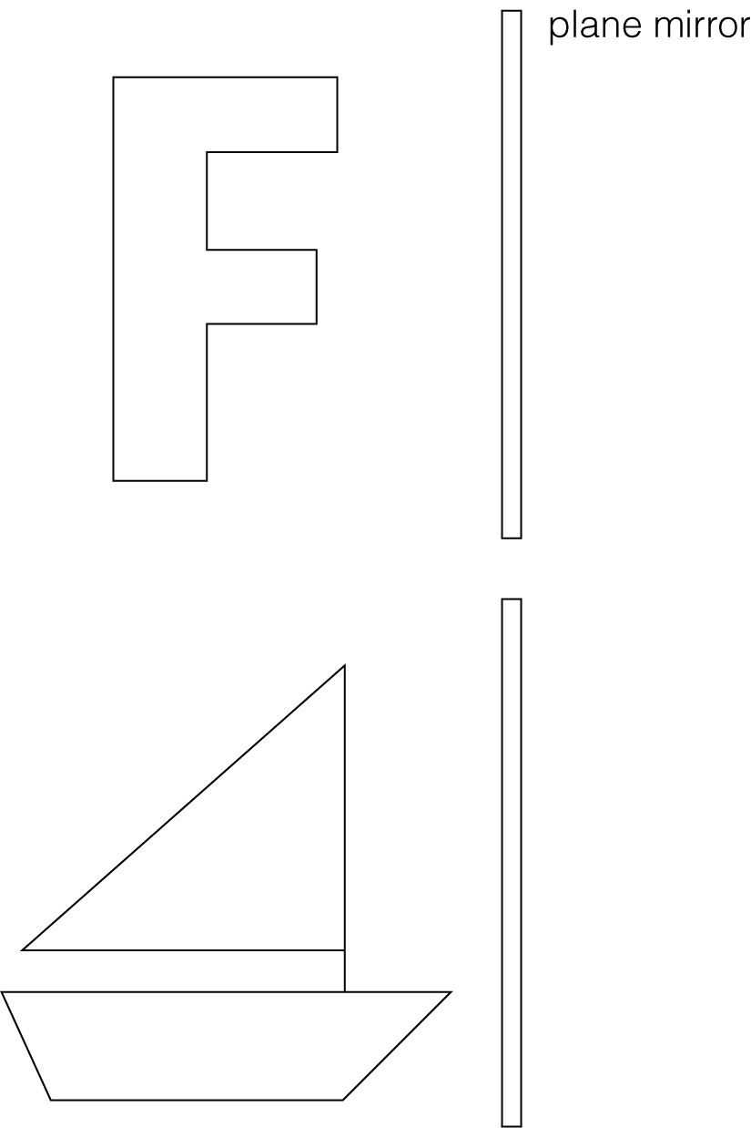

5. Were there any differences between the object and its image in the plane mirror
with respect to:
(a) size?
F _______________________ Sailboat _________________________
(b) distance from the mirror?
F _______________________ Sailboat _________________________
(c) orientation?
F _______________________ Sailboat _________________________

