Your Digestion System

Instructions:

Label each the parts of your digestive system using your text book

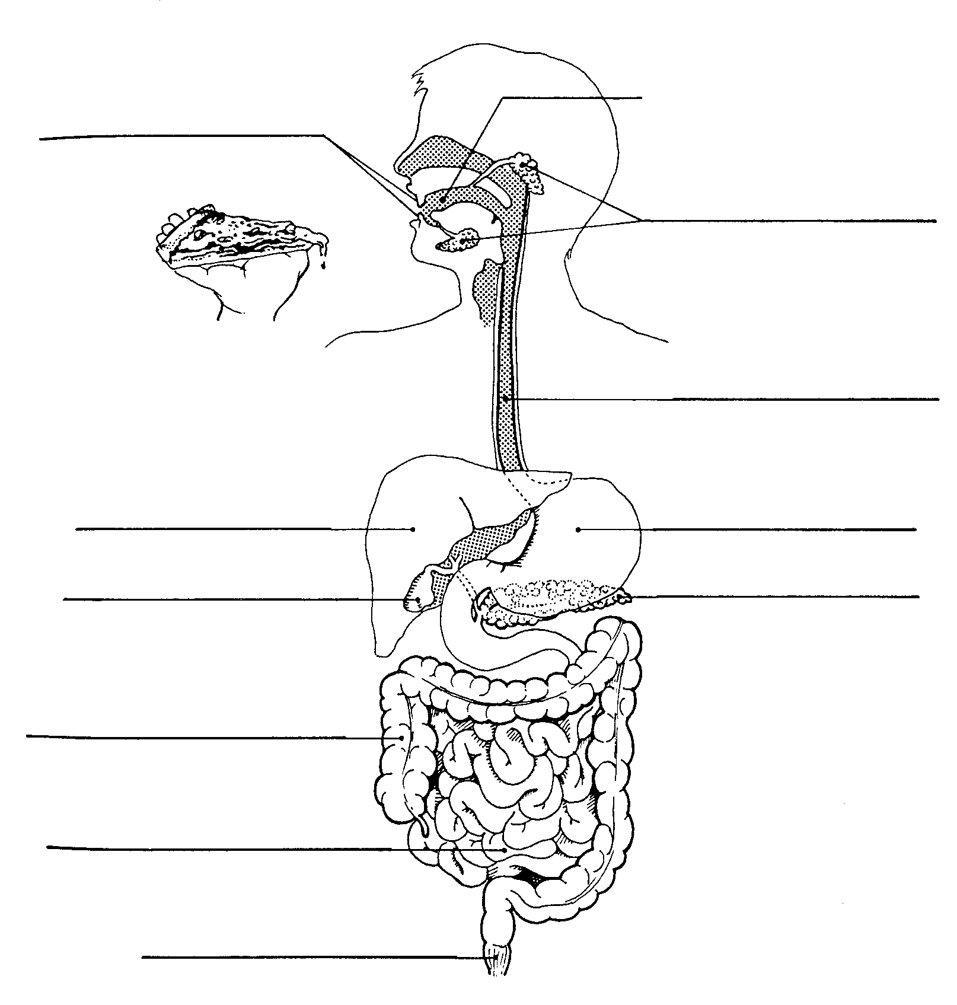

Instructions:
- Complete the following table using information from your notes and textbook
Structure | Function(s)
Mouth | Where food enters the mouth and undergoes mechanical and chemical digestion
Saliva | Lubricates the food and helps the food go down the esophagus. It’s produced from Salivary Amylase to help break down carbohydrates.
Esophagus | A long, muscular tube that connects the mouth to the stomach.
Epiglottis | Small, flap that covers the airway tube during swallowing to prevent food from entering the trachea.
Small Intestine | Digestion occurs in the duodenum which is the first 30cm of the S.I. Absorbtion of nutrients occurs in the rest of the S.I.
Large Intestine | To take undigested material from the small intestine and reabsorb the water and some minerals. Also contains bacteria which help producer some vitamins
Pancreas | Small organ that produces digestive enzymes that pass into the duodenum (small intestine).
Liver | Produces a substance called bile to help break down fats. Also helps to control blood sugar levels
Stomach | Stretchable muscular bag which can hold 2L of food or liquid. Contains gastric juice which is made from hydrochloric acid, mucus and enzymes to help break down food
Gall Bladder | Stores the Bile - bile is used to help break down fats into smaller particles that can be absorbed more easily
Rectum | Part of the Large intestine that ends up in the anus. Stores feces until it can be eliminated by the body.
Anus | An opening where solid waste is eliminated from the body.

