Eyeball Dissection

Purpose: To observe and dissect an eyeball and then to identify the parts of the eye that light passes through.

Materials/Procedure: As on pages 212- 213 of BC Science 8

Observations/Results:

PART I: OUTSIDE THE EYE_______________________________________________________________

- In what way, other than color is the muscle different from the fat?

- Why do you think there are so many muscles attached to the eyeball?

- What color is the iris in the eye that you are dissecting? __________________________________

- In a living animal, where would the optic nerve lead? ___________________________________

PART II: INSIDE THE EYE_________________________________________________________________
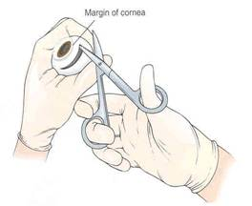
- Describe the shape of the lens. _______________________________________________________
- Can you see through the pupil? _______________________________________________________
- Describe the retina. Is it colored? ______________________________________________________
__________________________________________________________________________________________
- Why do you think the choroid is dark colored? __________________________________________
__________________________________________________________________________________________
DISCUSSION:
- List the parts of the eye in the order through which light passes as it travels through the eye to the retina.
__________________________________________________________________________________________
__________________________________________________________________________________________
- Make up a mnemonic (memory device) to help you remember the order.
__________________________________________________________________________________________
- What does each of the above parts do?

- __________________ _____________________________________________________________
_____________________________________________________________
- __________________ _____________________________________________________________
_____________________________________________________________
- __________________ _____________________________________________________________
_____________________________________________________________
- __________________ _____________________________________________________________
_____________________________________________________________
- __________________ _____________________________________________________________
_____________________________________________________________
- __________________ _____________________________________________________________
_____________________________________________________________
- __________________ _____________________________________________________________
- __________________ _____________________________________________________________
- __________________ _____________________________________________________________

