NOTES 5.3 Interpreting & Sketching Graphs
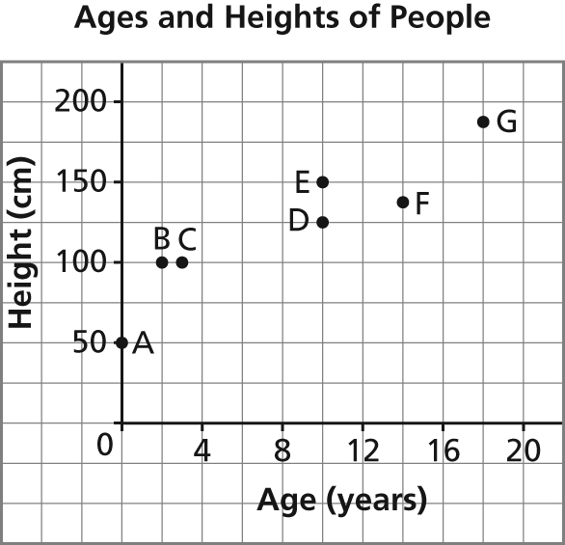
1. Each point on this graph represents a person.
a) Which person is the oldest? _________
What is her or his age?__________
b) Which person is the youngest? _________
What is her or his age? _________
c) Which two people have the same height? _________ What is this height? _________
d) Which two people have the same age? _________ What is this age? _________
e) Which of person B or C is taller for her or his age? _________

2. This graph represents a day trip from Athabasca to Kikino in Alberta, a distance of approximately 140 km. Describe the journey for each segment of the graph.
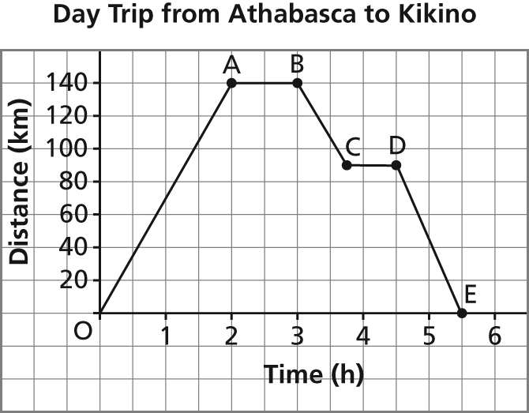

Segment | Graph | Journey
OA |  | The car leaves Athabasca and takes 2 h to travel 140 km to Kikino.
AB |  | The car stops for 1 h.
BC |  | The car starts the return trip. The car takes approximately 45 min to travel 50 km toward Athabasca.
CD |  | The car stops for approximately 45 min.
DE |  | The car takes 1 h to travel approximately  90 km to Athabasca.

3. At the beginning of a race, Alicia took 2 s to reach a speed of 8 m/s. She ran at approximately 8 m/s for 12 s, then slowed down to a stop in 2 s.
Sketch a graph of speed as a function of time. Label each section of your graph, and explain what it represents.

Segment | Journey
OA | Alicia’s speed increases from 0 to 8 m/s, so the segment goes up to the right for the first 2 s.
AB | Alicia runs at approximately 8 m/s for 12 s. Her speed does not change, so the segment is horizontal.
BC | Alicia slows down to 0 km/h in 2 s, so her speed decreases and the segment goes down to the right.

