The Electromagnetic Spectrum

**INSTRUCTIONS**

USING YOUR TEXBOOK (pg. 152-160), LABEL the diagram and fill in the following chart with information about each type of Electromagnetic Radiation.



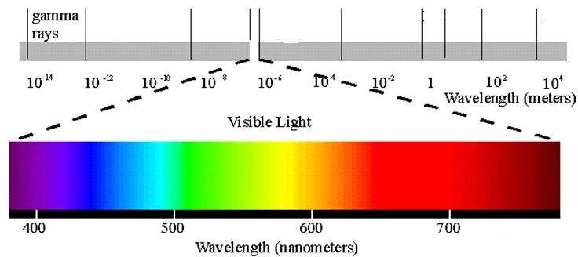



|  |  |  |  |  |
| --- | --- | --- | --- | --- |
| **TYPE OF RADIATION** | **WAVELENGHT** | **FREQUENCY** | **USES** | **DANGERS**  **CAUTIONS** |
| **RADIO WAVES** |  |  |  |  |
| **MICROWAVES** |  |  |  |  |
| **INFRARED** |  |  |  |  |
| **ULTRAVIOLET** |  |  |  |  |
| **X-RAYS** |  |  |  |  |
| **GAMMA RAYS** |  |  |  |  |