Parts of an Animal Cell
Below is a diagram of an animal cell. Label the parts of the cell. For assistance, turn to page 27 in BC Science 8.
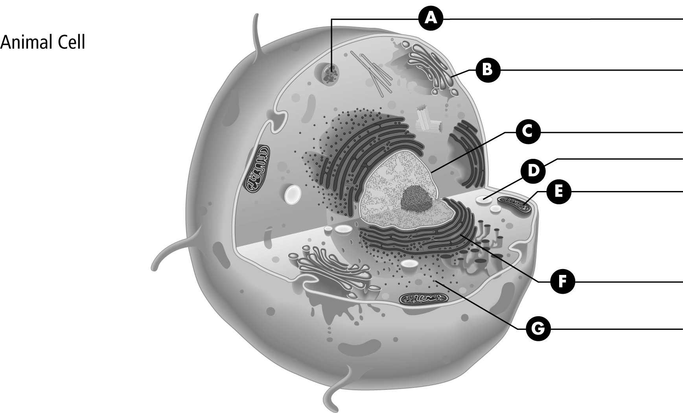

Organelle | Function | Diagram/Description
Endoplasmic reticulum | Transports proteins | Network of folded channels

Organelle | Function | Diagram/Description
Endoplasmic reticulum | Transports proteins | Network of folded channels
Cell membrane | Protects the cell and controls the movement of particles into and out of the cell | Surrounds the cell
Cell wall | Protects the cell and gives the cell a regular, box-like shape | A tough, rigid structure that surrounds the cell membrane
Cytoplasm | Contains organelles, water, and other life-supporting materials | Jelly-like substance
Nucleus | Controls all the activities within a cell | Contains DNA
Mitochondrion | Produces energy | Has an inner and outer membrane
Chloroplast | Traps energy from the Sun and changes it into chemical energy | May be a greenish colour
Vacuole | Temporarily stores substances and regulates water | Larger in plant cells
Vesicle | Moves materials into, out of, and around the inside of the cell | A membrane-bound sac that is smaller than a vacuole
Golgi body | Packages some materials for transport inside the cell or for transport out of the cell | Packs proteins into vesicles
Lysosome | Helps the cell break down large particles and old worn-out cell organelles | Contains digestive enzymes
Ribosome | Assemble proteins | Some float in cytoplasm and some are attached to endoplasmic reticulum

