NOTES 5.5 Graphs of Relations & Functions
1. Which of these graphs represents a function? Justify your answer.
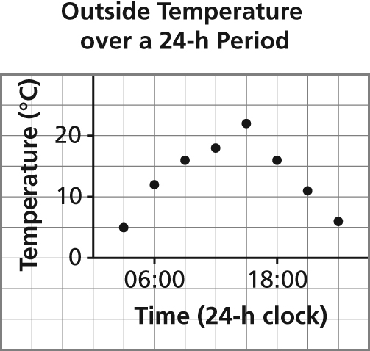
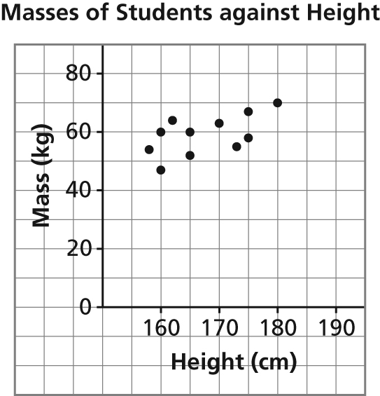
a) b)

2. Determine the domain and range of the graph of each function.
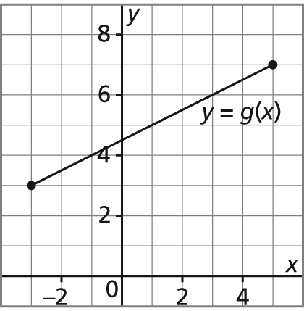
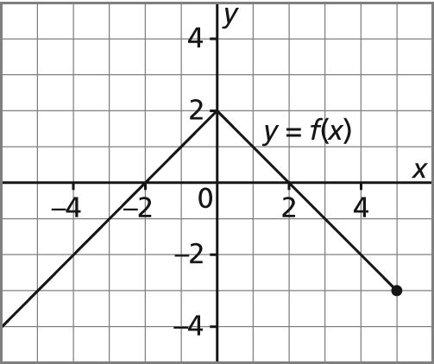
a) b)

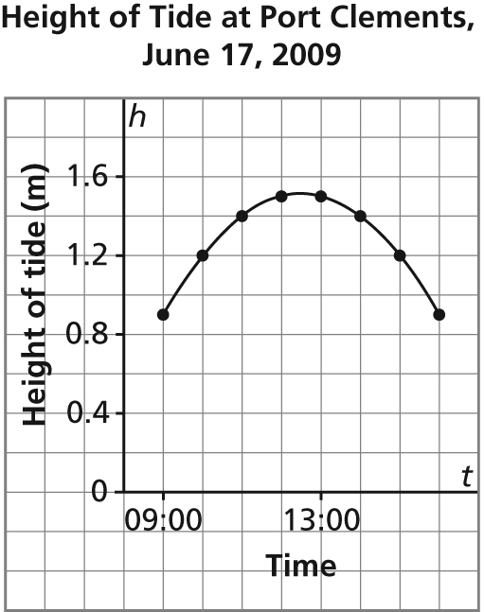
3. This graph shows the approximate height of the tide, h metres, as a function of time, t, at Port Clements, Haida Gwaii on June 17, 2009.
a) Identify the dependent variable and the independent variable. Justify your choices.
b) Why are the points on the graph connected? Explain.
c) Determine the domain and range of the graph.

4. Here is a graph of the function g(x) = 4x – 3.
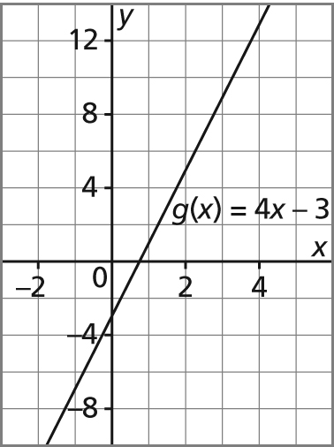
a) Determine the range value when the domain value is 3.
b) Determine the domain value when the range value is –7.

