Parts of a Plant Cell
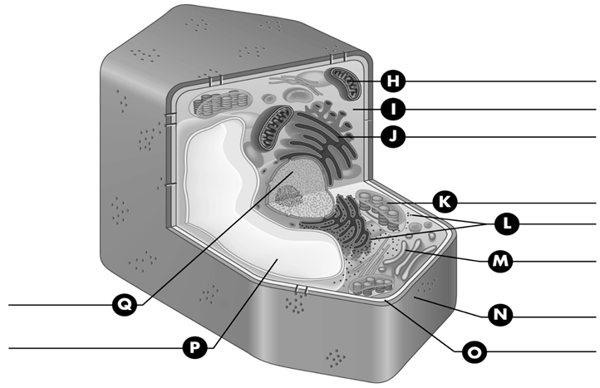
Below is a diagram of a plant cell. Label the parts of the cell indicated by each letter. For assistance, turn to page 27 in BC Science 8.

Cell Part | Description | Present in Animal Cell? (yes or no) | Present in Plant Cell? (yes or no)
Cell membrane
Cell wall
Cytoplasm
Nucleus
Mitochondrion
Chloroplast
Vacuole
Vesicle
Endoplasmic reticulum
Golgi body
Lysosome
Ribosome

