Solids, Liquids, and Gases

Complete the following table to describe three states of matter. The table has been partially completed to help you. Use the textbook pg. 246-253.



|  |  |  |  |
| --- | --- | --- | --- |
|  | **SOLID** | **LIQUID** | **GAS** |
| **Shape** |  | Not fixed; takes the shape of the container |  |
| **Volume** | Fixed volume |  |  |
| **Spaces between particles** |  |  |  |
| **Movement of Particles** |  |  | Can move freely and quickly in all directions in the container |

In each of the jars below draw the particles in a gas, a liquid and a solid. Make sure to indicate whether the particles are moving or vibrating in your diagrams.

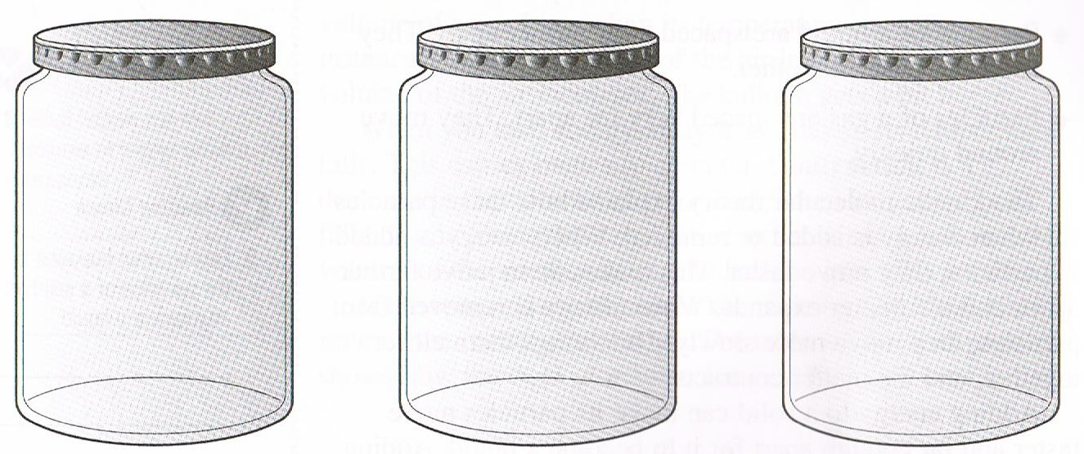



**SOLID LIQUID GAS**

