Three states of matter

Examine the diagram, and then answer the questions that follow.

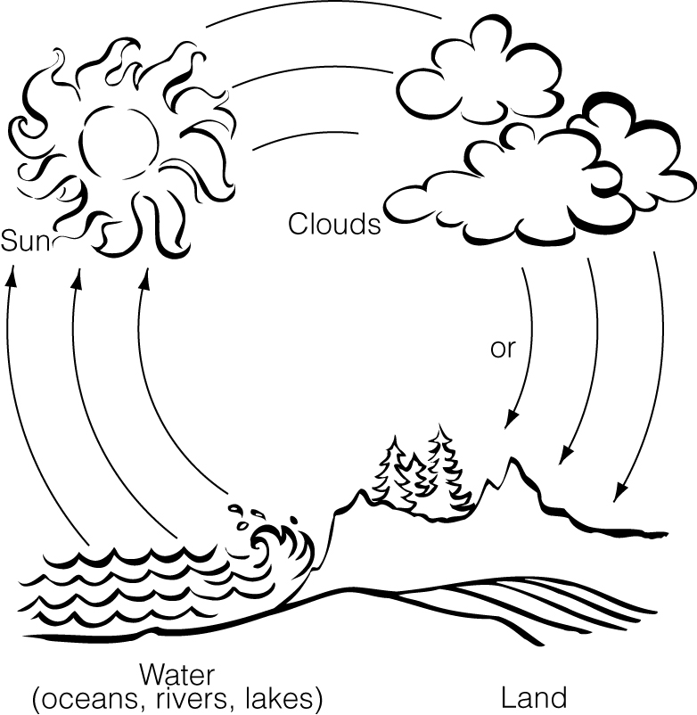

Questions

1. At which stages of the water cycle does water take its liquid state?



2. At which stages of the water cycle does water take its solid state?



3. At which stage of the cycle does water take its gaseous state?



4. When are all three states of matter present?

