Comparing Prokaryotic and Eukaryotic Cells
Use the Circle diagram below to compare and contrast a prokaryotic cell and a eukaryotic cell.

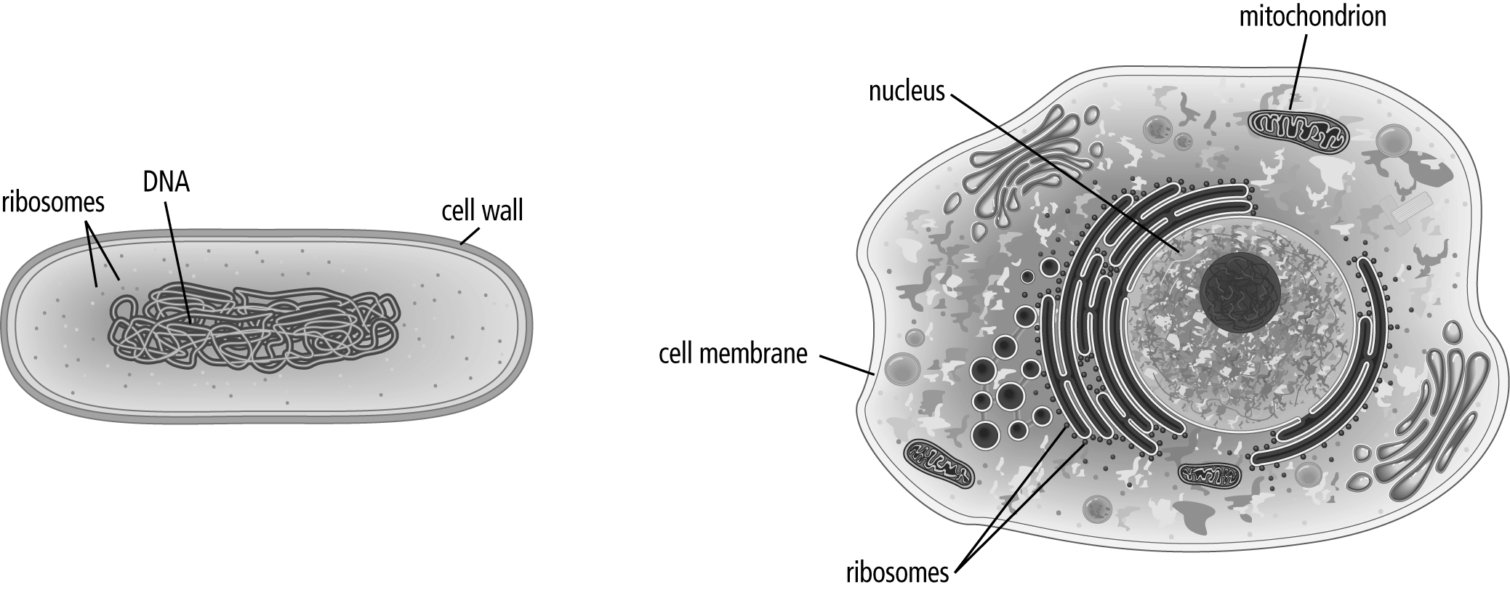

Eukaryotic Cell

Prokaryotic Cell

