What’s the Matter?

Use the terms in the vocabulary box to label the diagram. Place the terms on the numbered arrows.

**Vocabulary**

|  |  |
| --- | --- |
| Condensation  Deposition  Evaporation | Melting  Solidification  Sublimation |

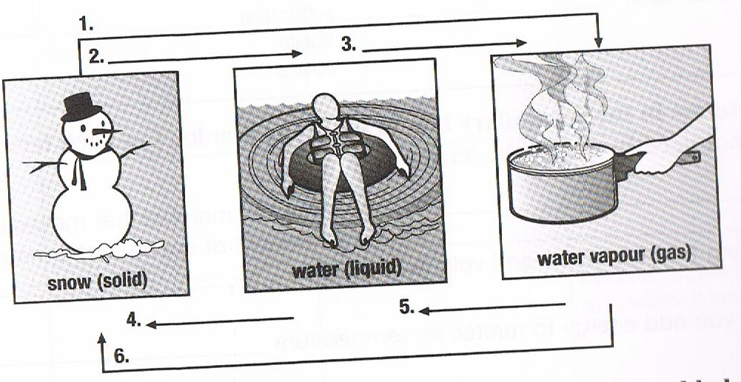



Complete the table by describing the change of state. The table has been partially completed to help you.

|  |  |  |
| --- | --- | --- |
|  | **Change of State** | **Heat added or released** |
| **Condensation** |  | Released |
| **Deposition** |  |  |
| **Evaporation** | Liquid to gas |  |
| **Melting** |  | Added |
| **Solidification** |  |  |
| **Sublimation** |  |  |