C:\Users\Nindi\AppData\Local\Microsoft\Windows\Temporary Internet Files\Content.IE5\LCA347Q2\MC900290272[1].wmfAssignment #3: Factors /26

**MULTIPLE CHOICE (2 marks)**

**1.** The greatest common factor of 36, 20, and 40 is:  
**A.** 360 **B.** 4 **C.** 2 **D.** 1

**2.** Which polynomial is a perfect square trinomial?  
**A.** 9*x*2 + 49 **B.** 9*x*2 + 16*x* + 49 **C.** 9*x*2 – 49 **D.** 9*x*2 –42*x* + 49

|  |  |  |
| --- | --- | --- |
| **3. a)** Determine the cube root of 5832.  (1 mark) | **b)** Determine the square root of 256. (1 mark) | **c)** Determine the least common multiple of the roots in parts a and b. (1 mark) |

**SHORT ANSWER (24 marks)**

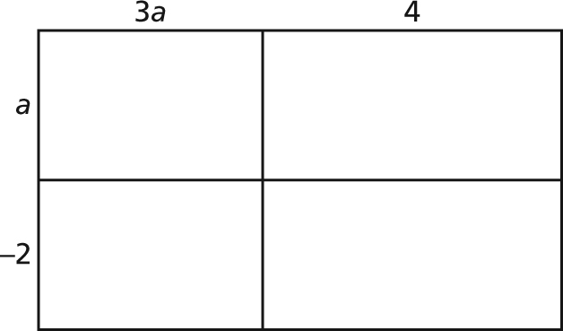**4.** **a)** Complete this diagram by sketching **b)** Complete this rectangle diagram.  
the tiles that represent the product. Write the multiplication sentence  
Write the multiplication sentence the diagram represents. (2 marks)  
the diagram represents. (2 marks)

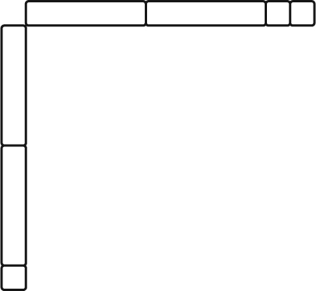

**c)** How can you check that the multiplication sentences in parts a and b are correct? (1 mark)

**5.** Expand and simplify. (3 marks)

**a)** (4*r* + 6)(3*r* – 6) **b)** (2*x – y*)(*x*2 – 6*xy* – *y*2)

**c)** (3*a* + 2*b*)(*a* – *b*) – (2*a* + *b*)(2*a* – 3*b*)

**6.** Factor each polynomial. Verify by multiplying the factors. (6 marks)

**a)** 8*a*2*b* – 4*ab*2 **b)** 8*h*2 – 18*k2*

**c)** 16*f*2 + 8*f* + 1 **d)** 6*m*2 – *m* – 2

**e)** 10*x*2 – 29*xy* + 10*y*2 **f)** *r*2 – 2*r* – 15

**7.** Find and correct the error in this factorization: 3*a*2 – 7*a* – 6 = (3*a* – 2)(*a* + 3) (2 marks)

**8.** A right rectangular prism has dimensions *r* by *3r +* 1by 2*r +* 2.

**a)** Write and simplify a polynomial for the surface area of the prism. (2 marks)

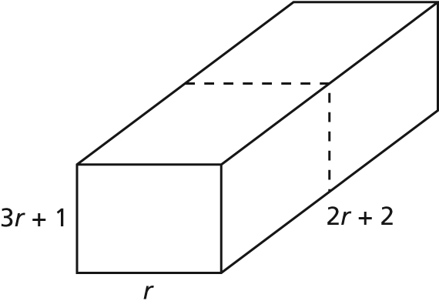

**b)** The prism is cut in half along the broken line shown. Write and simplify a polynomial for the surface area of each smaller prism. (2 marks)

**c)** Factor each trinomial in parts a and b. Why is the surface area in part a not two times the surface area in part b? (1 mark)