MC900290272[1]Assignment #6: Linear Functions /32

**MULTIPLE CHOICE (2 marks)**

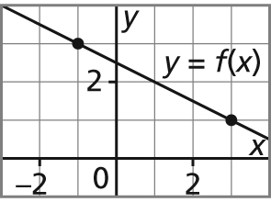**1.** What is the slope of this line?

**A.** –2 **B.  C. ** **D.** 2

**2.** Which equation is **not** equivalent to the others?

**A.** *y* – 8 = (*x* + 8) **B.** *y* = *x* + 4 **C.** 3*x* + 2*y* – 8 = 0 **D.** *y* + 2 = (*x* – 4)

**SHORT ANSWER (30 marks)**

**3.** **a)** Determine the slope of each line. (4 marks)

**i)** a line that passes through A(–4, 7) and B(6, 3)

**ii)** a line described by the equation 5*x* – 2*y* + 7 = 0

**b)** Are the lines in part **a)** parallel, perpendicular, or neither? Justify your answer. (2 marks)

**4.** Graph each equation. Describe the strategies you used. (6 marks)

**a)** *y* – 2 = –2(*x* + 3)



**b)** 2*x* – 5*y* + 10 = 0



**c)** *y* =  – 2



**5.** **a)** Write an equation for each graph. Describe your strategy. (4 marks)

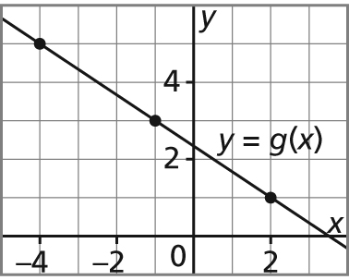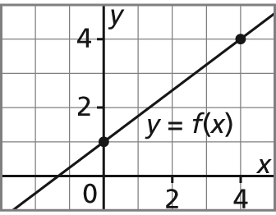 **i) ii)**

**b)** Write each equation in part **a)** in general form. (2 marks)

**c)** Use a point on the line to verify **EACH** equation. (2 marks)

**6.** **a)** Write an equation for the line that passes through E(4, –3) and is parallel to the line

*y* + 1 = (*x* – 4). Write the equation in general form. (2 marks)

**b)** Write an equation for a line with *x*-intercept –3 and *y*-intercept 5.

Explain your strategy. (2 marks)

**7.** Josie started a part-time job when she was 16. Each month, she put a fixed amount into her savings account. After 4 months, Josie had $770 in her savings account. After one year, she had $1450 in her savings account.

**a)** Write an equation to describe this relation. Write your equation in slope-intercept form.

(2 marks)

**b)** How much money will Josie have after 2 years? (2 marks)

**c)** How long will it be until Josie has $4000 in her savings account? (2 marks)