C:\Users\Nindi\AppData\Local\Microsoft\Windows\Temporary Internet Files\Content.IE5\LCA347Q2\MC900250659[1].wmfAssignment #2: Trigonometry /15

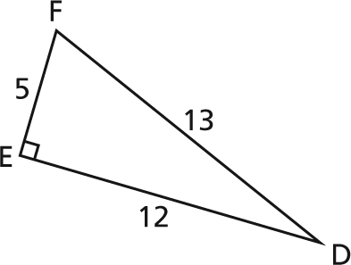**MULTIPLE CHOICE (2 marks)**

**1.** For ∆DEF, how many of these statements are true?  
cos ∠D =  sin ∠D =   
tan ∠D =  tan ∠F = 2.4

**A.** 1 is true. **B.** 2 are true. **C.** 3 are true. **D.** All are true.

**2.** In right ∆DEF, with ∠E = 90°, which statement is false? As ∠D decreases:

**A.** sin ∠D increases. **B.** sin ∠F increases. **C.** cos ∠D increases. **D.** cos ∠F decreases.

**SHORT ANSWER (13 marks)**

**3. a)** Solve each triangle. Give your answers to the nearest tenth. (6 marks)

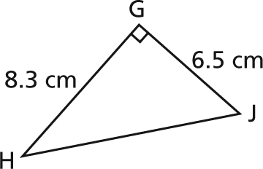

**i)**

**ii)** Right ∆KMN with ∠M = 90°, ∠N = 26°, and KN = 15.0 cm.

**b)** When you solved the triangles in part a, did you use the same strategies? (1 mark)  
If your answer is yes, describe your strategy.  
If your answer is no, explain why you used different strategies.

**4.** The angle of inclination of a conveyor is 8°. The conveyor rises 0.75 m. What is the length of the conveyor? Give your answer to the nearest hundredth of a metre. (2 marks)

**5.** A helicopter is hovering at a height of 300 m. From the helicopter, the angle of depression of the top of a wind turbine is 40° and the angle of depression of the base of the turbine is 48°. Determine the height of the turbine, to the nearest tenth of a metre. (4 marks)

C:\Users\gill_narinder\AppData\Local\Microsoft\Windows\Temporary Internet Files\Content.IE5\AQX7DSGK\MC900437705[1].wmf

?

300 m