Description | Explanation | Cell Picture
This is a picture of a normal plant cell.  The large central vacuole is not losing or gaining water. | No water is diffusing into the cell or diffusing out of the cell.  This is because water is in the same concentration inside the cell compared to outside the cell. | 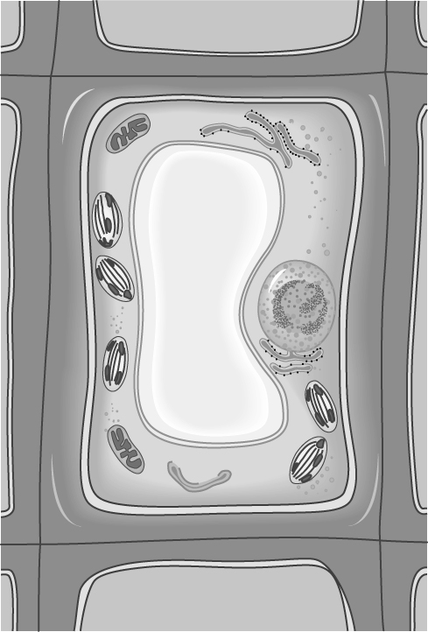
 |  | 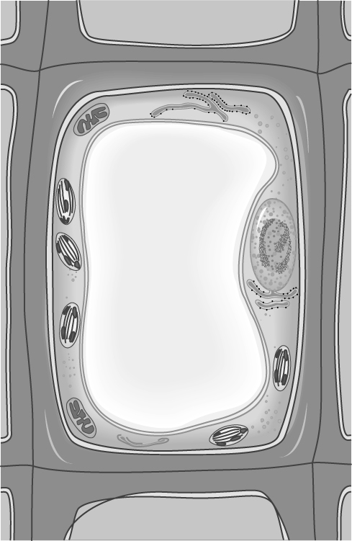
 |  | 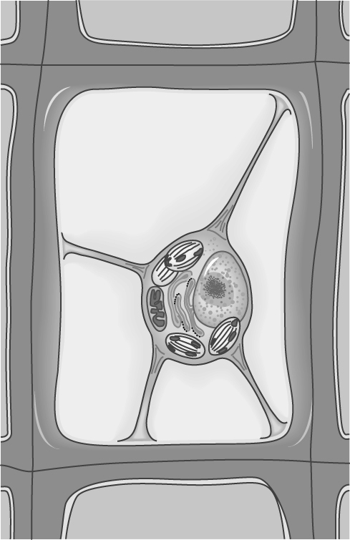

Osmosis in Plant Cell
Using the text, pg.45, Figure 1.35, fill out the following table.
Follow up Questions:
1. Is the plant cell membrane and cell wall permeable to water? How do you know?

2. A grape is added to a beaker of water. Several hours later it is swollen. Explain why.

3. Why do supermarkets spray their vegetables? Explain what is happening to the cells of these vegetables.

4. What would happen to the cells of a salmon when it leaves its salt water (ocean) environment to spawn in a fresh water river?

Bonus Question:
Why would climbing Mount Everest (without oxygen tanks) decrease the amount of energy a person could produce? (Think about mitochondria)

