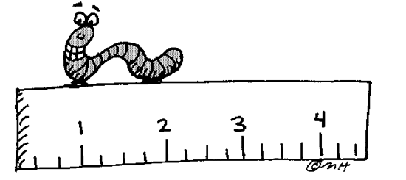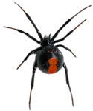**LESSON 1.1 REFLECTIONS & LINE SYMMETRY**

**Line of symmetry:**

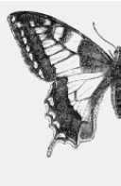

1 Line of symmetry

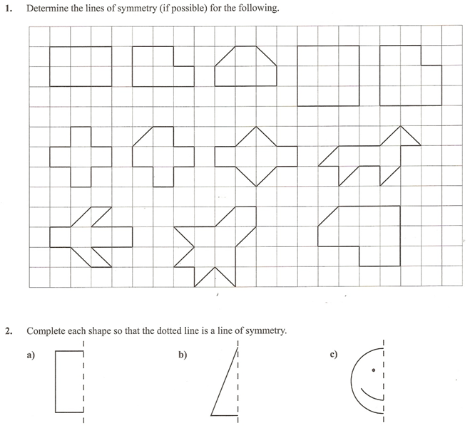

*Example 1*

*Example 2*

Identify the triangles that are related to the red triangle by a line of reflection.

Describe the position of each line of symmetry and draw on the graph



*Example 3*

We can use a coordinate grid to draw shapes and their reflection images

Completing a shape given its line of symmetry. Quadrilateral ABCD is part of a larger shape.

|  |  |
| --- | --- |
| Point | Image |
| A (2, 2) | A ( , ) |
| B (4, 4) | B’ ( , ) |
| C (6, 4) | C’ ( , ) |
| D (6, 2) | D ( , ) |

Draw the image of ABCD after each reflection below



i. A reflection in the

horizontal line through

2 on the y-axis.



|  |  |
| --- | --- |
| Point | Image |
| A (2, 2) | A’ ( , ) |
| B (4, 4) | B’ ( , ) |
| C (6, 4) | C ( , ) |
| D (6, 2) | D ( , ) |

ii. A reflection through

a vertical line through 6 on

the x-axis

|  |  |
| --- | --- |
| Point | Image |
| A (2, 2) | A ( , ) |
| B (4, 4) | B ( , ) |
| C (6, 4) | C’ ( , ) |
| D (6, 2) | D’ ( , ) |



iii. A reflection in

an oblique line through (0,0)

and (6, 6)