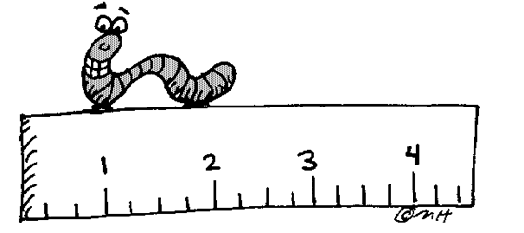**LESSON 1.2: ROTATIONS & ROTATIONAL SYMMETRY**

**Jumpstart Your Thinking**

State the number of lines of symmetry for each shape









A tracing of this shape is rotated around its centre. We draw a line segment to help identify the angle the shape turned before it met up with itself



**Rotational Symmetry** –



**Order of Rotation** –







* **A**



*Example 1*

1. Which hexagons below have rotational symmetry? State the order of rotation and the angle of rotational symmetry.





1. Join one vertex to the red dot
2. Rotate the tracing about the red dot and record the order of rotation.



1. Calculate the angle of rotation symmetry



1. The order of rotation = ____________



The angle of rotation symmetry = _________ = 120o



b. The order of rotation = ____________



The angle of rotation symmetry = _______________



c. The order of rotation = ____________



The angle of rotation symmetry = _______________

