Blood Flow in the Heart



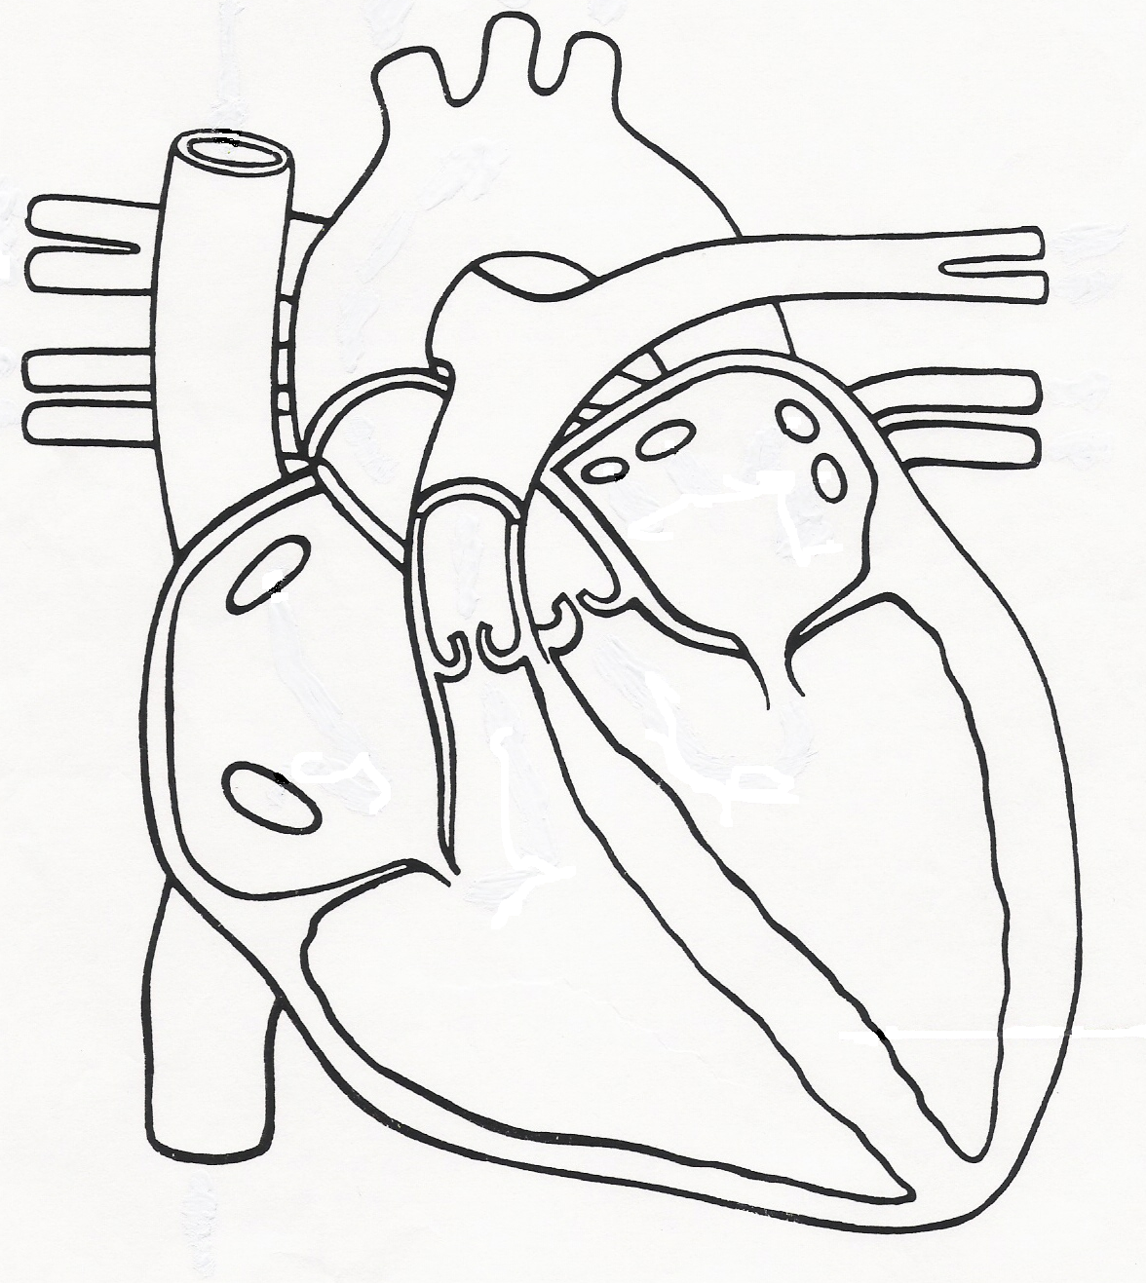



Right atrium

Right ventricle

Left atrium

Left ventricle

Superior

Vena Cava

Inferior

Vena Cava

Pulmonary

veins

Pulmonary veins

Aorta

Pulmonary arteries