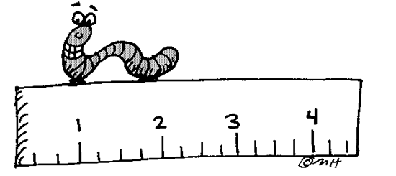**LESSON 4.1: SCALE DIAGRAMS & ENLARGEMENTS**

**Jumpstart Your Thinking** Write some definitions down

Scale Diagram



__________________________________________________________________________________________________________________________________________________



Corresponding lengths



__________________________________________________________________________________________________________________________________________________



**Let’s look at the math**

*Example 1*

Determine how big the drawing is below and compare is to its scale diagram.



Actual size



* length: ___________



* width: ____________



Enlargement size



* length: ____________



* width: ____________



Write a fraction for each comparing enlarged size length to the actual length. Do the same for the width measurements below using the fraction:



$\frac{length on enlargement}{length on actual size drawing}$ $\frac{width on enlargement}{width on actual size drawing}$

What do you notice about these numbers?



_________________________________________________________________________



***Example 2***

Circle the corresponding lengths of these two diagrams.



Scale factor = $\frac{length on enlargement}{length on actual size drawing}$



Scale factor =



A scale factor can be expressed as a _____________ or a _________________.



When two ratios or corresponding lengths are equal we can say that they are ___________________________.



*Example 3*

**Using Corresponding Lengths to Determine the Scale Factor**

The drawing of this mosquito was printed in a newspaper article about the West Nile Virus. The actual length of the mosquito is 12mm. Determine the scale factor of the diagram.





**LESSON 4.2: SCALE DIAGRAMS & REDUCTIONS**

**Jumpstart Your Thinking**

Find the scale factor of the picture below:







60





36



27

17



20



32



Scale Factor = ____________



**Let’s look at the math**

*Example 1*

* Determine the scale factor for its diameter and heart

*Remember:*

*Scale factor = $\frac{length on reduction}{length on actual size drawing}$*



Scale factor



* Heart = ___________



* Diameter = ___________



* If the corresponding lengths are proportional (the same) then the scale factor is _____. (a fraction or decimal)



What do you notice about the reduction scale factors compared to the enlargment scale factors?



__________________________________________________________________________________________________________________



***Example 2***

A scale may be given as a ratio; as seen when you look at maps or house diagrams. A scale of 1:100 can mean that every 1 cm on the diagram = 100 km in the real world.



1. Look at the map of Victoria Island – use the scale to determine:





1. The distance from Holman to Cambridge Bay?



1. How wide is Victoria Island?



***Example 3***

1.  Here is the scale diagram of the top view of a truck.



The length of the truck is 4 m.

* 1. The front and back wheels of the truck are 3.85m apart. How far apart should the wheels be on the scale diagram?



* 1. What is the width of the truck?

