4. 3 Another Form of the Equations for a Linear Relation
Jumpstart Your Thinking
Graph the following equations

x = 3 y = -2

The x-coordinates for every point The y-coordinate for ever point
on this line is x = 3 on this line is y = -2
…(3,-2)(3,-1)(3,0)(3,1)(3,2)… …(-2,-2)(-1,-2)(0,-2)(1,-2)2,-2)…

Let’s Look at the Math

The graph of the equation x = a, where a is a constant, is a vertical line. Every point on the graph has an x-coordinate of a.

The graph of the equation y =a, where a is a constant, is a horizontal line. Every point on the graph has a y-coordinate of a.
1. a) x – 4 = -8 Isolate x b) 2y = 7 Isolate y

y
x
8

8

-8

-8

yyy
xxx
888

888

-8-8-8

-8-8-8

2. Does each equation describe a vertical, a horizontal, or an oblique line?
a) y = 4 b) 2x + 5 = 7

c) 2x – y = 6 d) 3y + 9 = 0

3. Which equation below describes each graph? How do you know?
a) b)
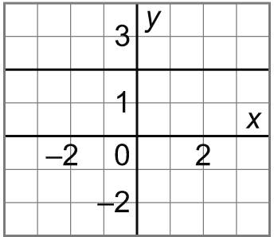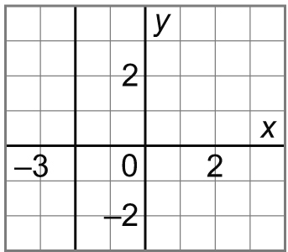
i) x = 2 ii) x = –2
iii) y = 2 iv) y = –2

Jumpstart Your Thinking
4. Graph each line. Explain your work.
a) x = 4 b) 2y = 6

c) y – 2 = –6 d) 2x + 3 = 8

y
x
8

8

-8

-8

y
x
8

8

-8

-8

Let’s Look at the Math…
Some equations can be written with both variables on the same side but they can still represent a linear relation. Let’s take a look.

5. Graph 3x – 2y = 6
a) Set up a table of values using the x values given.
 | x | y
 | -4
 | -2
 | 0
 | 2
 | 4

b) Graph the equation.
y
x
8

8

-8

-8

6. Graph: 5x – y = 3; for x = -2, -1, 0, 1, 2
y
x
8

8

-8

-8

 | x | y

