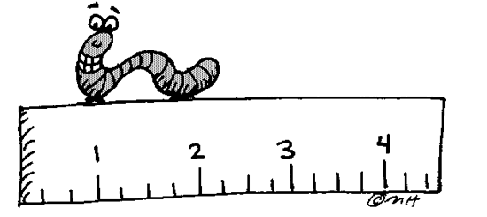**LESSON 4.3: SIMILAR TRIANGLES**

**Jumpstart Your Thinking**

Identify two triangles in this diagram. How could you find out if they are similar?





**Let’s Look at the Math**

When two polygons are similar:



* The measures of _______________________________________________________



* The ratios of __________________________________________________________



***Example 1***

Identify if the triangles below are similar. Justify your answer



a. Write down the lengths of ∆PQR from shortest to longest _________________________________



b. Write down the lengths of ∆ STR from shortest to longest __________________________________



c. Find out if the corresponding sides are proportional



***Example 2***



At a certain time of day, a person who is 1.8 m tall has a shadow 1.3 m long. At the same time, the shadow of a totem pole is 6 m long. The sun’s rays intersect the ground at equal angles. How tall is the totem pole to the nearest tenth of a metre?



***Example 3***



This statue, honouring Ray Hnatyshyn (1934–2002), can be found on Spadina Crescent East, near the University Bridge in Saskatoon. Use the information below to determine the unknown height of the statue (including base).





***Example 4***

A surveyor wants to determine the width of a lake at two points on opposite sides of the lake. She measures the distances and angles on land, and then sketches this diagram. How can the surveyor determine the length HN to the nearest metre?

