4.4 Matching Equations & Graphs
Jumpstart Your Thinking
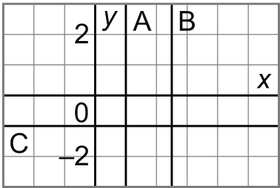
Match each equation with a graph on this grid.
a) y = – 1

b) 0 = –x + 1

c) 2 = 2x – 3

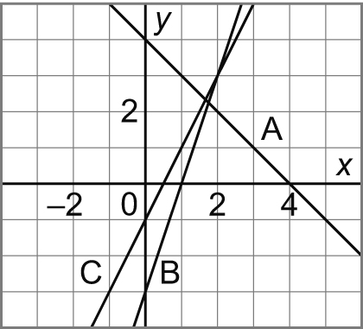Let’s Look at the Math
1. Match each equation with a graph on this grid.
Use the equation to determine the coordinates
of 3 points

a) y = 2x – 1

x=0

x= -1

x= 2

b) y = –x + 4 c) y = 3x – 3

x=0 x=0

x= -1 x= -1

x= 2 x = 2
2. Which equation describes this graph?
Pick two points on the graph and check to see which equation it satisfies.
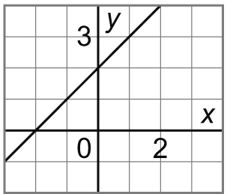

a) y = x – 2

b) y = –x + 2

c) y = x + 2

