DNA

**The Nucleus: Control Centre of The Cell**

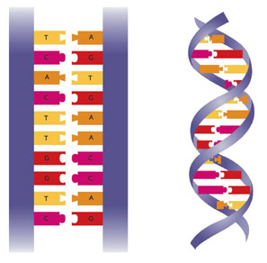The instructions in the nucleus are carried in long, two-stranded molecules called _________________ _____, or _____. The DNA molecule looks like a twisted __________. The two strands, or sides, of the DNA ladder wrap around each other in a spiral shape that scientists call a ________ ______ . The sides of the DNA ladder are made of ________ and __________. The steps of the ladder are made of four __________ bases, which are represented by the letters A (_________), G (_________), C (__________), and T (__________).

**The Arrangement of Bases in DNA Directs All Cell Activities**

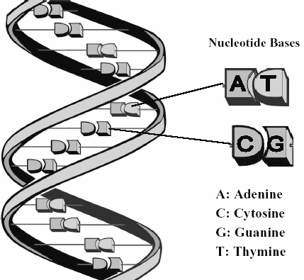Everything that occurs within a cell is the result of how the bases on the DNA molecule are __________. DNA molecules always join in a specific way:

* A always joins with ___
* G always joins with ___

However, the ______ and ________ of these bases can vary greatly within the DNA molecule. In humans, a single DNA molecule can be several _________ base pairs in length.

**DNA is Stored in Chromatin**

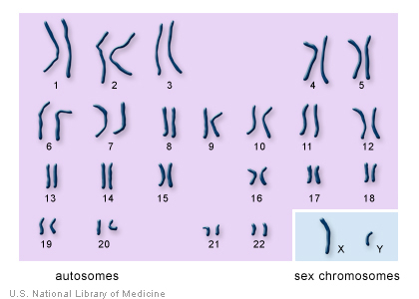Most of the time, DNA exists in the nucleus in the form of __________. Chromatin is a substance that contains DNA and _________. Within each strand of chromatin is one molecule of DNA. When a cell is growing, the DNA is ________ and aids in the manufacture of proteins the cell requires. When a eukaryotic cell is ready to divide, each strand of chromatin coils up into a very compact, _________ structure called a ___________.

**Every Organism has a Characteristic Number of Chromosomes**

Chromosomes within the nucleus are found in ______. Most human cells have ____ chromosomes arranged in 23 pairs, including one pair of chromosomes that help determine sex. In males, the 23rd pair of chromosomes is the ___ pair and in females is the ___ pair. Every living thing has a characteristic number of chromosomes.

**Genes are found on Chromosomes**

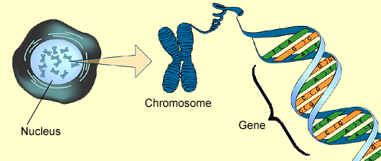______ are small segments of DNA located at specific places on a chromosome. Genes store the information needed to produce up to 100,000 different ________ used in the cells of your body. Genes can vary in length from hundreds to thousands of ______. Every chromosome carries thousands of _______ and therefore contains the information to make thousands of different proteins.

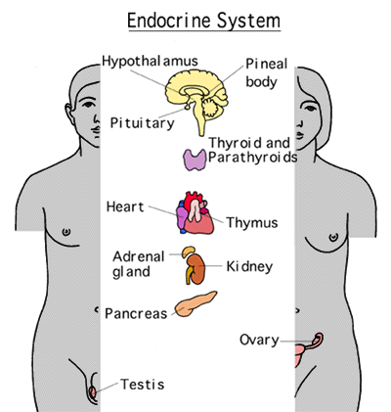**Proteins Determine What Body Cells Will Become and How They Function**

Each of your body cells contains the _____ amount of genetic information stored within its 46 chromosomes, but only specific ______ are “read” in each cell to produce specific proteins. By making specific proteins, a cell becomes __________ to carry out a particular function. Therefore, proteins needed to make your muscles work are made only in your _________ cells. Thousands of different, specialized proteins called ________ speed up the hundreds of chemical reactions that occur within each cell. For example, digestive enzymes work in chemical reactions to break down ______ into nutrient molecules that provides ________ for the cell. Some proteins act as chemical messengers called __________. For example, growth hormone functions to prepare a cell for _____________ by ensuring the cell has enough nutrients to divide.

**How Proteins are Produced**

1. The Nucleus receives a chemical signal to make a specific _________.
2. The DNA message for a specific protein is ______ into a small molecule called ___________ ___ or RNA.
3. RNA leaves through a nuclear ______.
4. The RNA message is delivered to the ___________, and the ribosomes make the protein.
5. The manufactured protein enters the __________ _________.
6. A _________ forms off the end of the endoplasmic reticulum and carries the protein to the Golgi body.
7. The Golgi body repackages the protein for ___________ out of the cell.
8. A vesicle forms off the end of the Golgi body to carry the protein to the cell __________.
9. 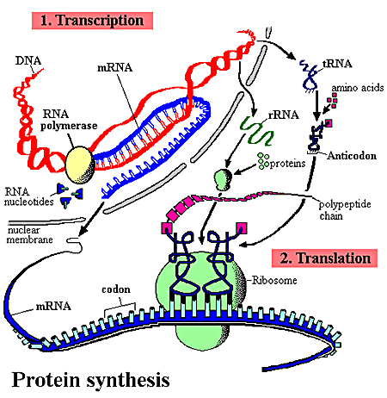The vesicle attaches to the cell membrane, and its protein contents are __________ out of the cell.