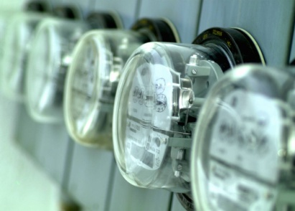Reading Electric Meter Dials

For each of the following meters, determine the meter reading.

1.



2. On December 1, the electric meter read 75 224 kWh. On January 1, the meter read 76 920 kWh. The cost of electrical energy is $0.28/kWh.

1. Calculate the energy consumed during the month of December. (1)
2. What did the electricity cost for the month? (1)

3. The dials below show the electric meter of the Lee family during the month of

.

(a) How much electrical energy was used during the month?

(b) If electrical energy cost $0.0675/kW•h, what was the electric bill for the month?

4. The dials below show the electric meter of a small business during the month of



(a) How much electrical energy was used during the month?

(b) If electrical energy costs $0.0691/kW·h, what was the electric bill for the month?