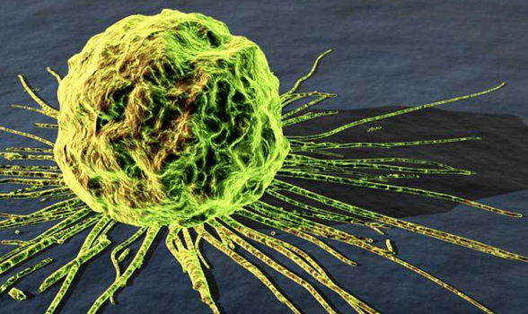
Cancer
Cancer is a disease that everyone has heard about but that few people understand. Statistics tell us that one out of every three Canadians will get cancer at some point in their lives. Most cancers are found in the middle aged or older people. However, in most of these people the cancer has been growing for many years before they recognize it.

Normal cells do not divide unless they are given a signal by the body to start mitosis. If a cell has been damaged or died, your body will direct nearby cells to divide to replace it. A cancer occurs when a cell goes “wild” and starts dividing uncontrollably to form a tumour. Cancer cells do not follow any directions given by the body. Cancer kills people because the tumours spread to important body organs such as the lungs or the brain and prevent them from functioning normally.

Cancer cells look abnormal under a microscope. They are often larger than normal cells, have two or more nuclei, and have an abnormal number of chromosomes.
In general, all cancer cells have four features in common:

- All cells of the cancer originally come from 1 wild cell.
- The cell divides continuously and out of control of the body.
- The cell can separate from its neighbours, move to a new location and grow into a new tumour.
- The cell has an abnormal number of chromosomes.

A normal cell can become a cancer cell if the part of its DNA that controls cell division becomes damaged. Scientists believe that there are four different things that can change the DNA of a cell so it becomes cancerous.

- Error in DNA replication.
- Exposure to radiation.
- Virus infection
- Chemical carcinogen (e.g. Chemicals in cigarette smoke)

Everyday a few normal cells turn into wild cells in your body. Luckily your body has means of recognizing these changed cells and destroying them. All you cells have the same unique pattern of protein molecules in their cell membrane. These proteins are called ANTIGENS and like fingerprints, every person has their own unique different antigens. The white blood cells in your body act as police. But instead of checking fingerprints or ID cards, your white blood cells check the kinds of proteins on the surface of every cell they touch as they travel around the body.

When your white blood cells discover a cell with different antigens they signal the body to produce ANTIBODIES. Antibodies are very specific and will only work for one type of antigen. When antibodies are released in your body, they act like guided missiles, ignoring all normal cells until they attach on to the strange antigens of a bacteria or cancer cell. The antibody then sinks a hole into strange cell’s membrane which causes the cell to explode and die. In this way your body recognizes and kills bacteria and cancerous cells.

Cancer treatments try to kill cancerous cells without harming normal cells. The different treatments are: Chemotherapy (using chemicals to attack the cancer cells), radiation therapy and finally surgery to remove cancerous tumours.

Although most cancer patients are older, doctors believe that their cancers began when these people were much younger. Many cancers can be avoided by the following changes in lifestyle:
- Avoid carcinogens such as cigarette smoke, smokeless tobacco (“chew”), smoked or pickled foods, burnt or BBQ food, and industrial chemicals and pollutants.
- Protect yourself from too much sunlight.
- Eat foods that help your body destroy carcinogens and cancer cells. These include: foods high in Vitamin A, Vitamin C and Vitamin E.
- Eat vegetables in the cabbage family (broccoli, cabbage, brussel sprouts…), which have special chemicals that help protect against cancer.
- Make sure that you eat lots of fibre rich foods.

Cancer can be most easily treated in its early stages before it has had a chance to spread to other organs. Be aware of changes in your body; watch for changes in the size and colour of moles. Ask a doctor to check any sores or lumps that don’t go away. Women should practice Breast Self Examination while men should do a regular Testicular Self Examination.

Questions:
- How is a cancer cell different from a normal cell?

- What different factors can cause a cell to become cancerous?

- How does your body recognize a cancerous cell?

- How does your body kill a bacteria or cancer cell?

- What factors in your lifestyle could increase your risk of getting cancer?

- What would you be willing to change in your lifestyle to avoid cancer?

