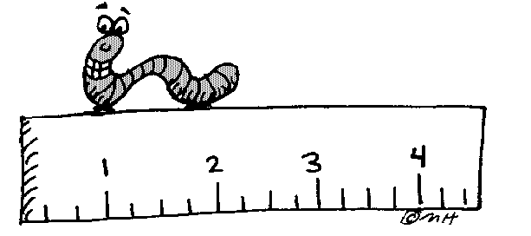**LESSON 4.4: SIMILAR FIGURES**

**Let’s look at the math**

Identify pairs of similar rectangles. Justify your answer.





1. What is the measure of all the angles within the rectangles? ________



1. Determine the corresponding sides and compare:
2. ABCD to EFGH



1. ABCD to JKMN



1. EFGH to JKMN



***Example 1***



These two octagonal plots are similar.

a. Calculate the length of GH.



b. Calculate the length of NP





