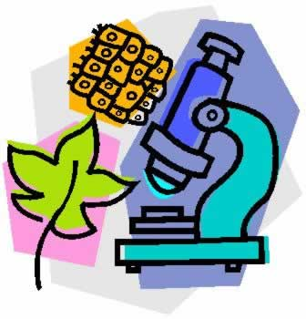

Biology Picture Dictionary
Picture Dictionary
- Define each of the terms in your own words.
- Draw and color a small thumbprint sized picture to represent each of the words.
- The picture can be anything that helps you to remember the definition of the word

....OR....

2. Crossword Puzzle
- Use a free online program found at websites such as:

1. http://www.puzzle-maker.com/CW/index.htm

2. http://puzzlemaker.discoveryeducation.com/CrissCrossSetupForm.asp

- You must include a blank copy of the crossword with clues as well as a copy that is filled in (answer key).
- If there are more than 25 words in a chapter, the words need to be split between 2 crossword puzzles.
- Your clues should be abbreviated definitions/in your own words. Please do not use the entire definition from the back of the textbook!

  - binary fission
  - budding
  - cancer
  - cell cycle
  - chromosomes
  - clones
  - DNA
  - embryonic development
  - fertilization
  - fragmentation
  - gametes
  - genes
  - meiosis
  - mitosis
  - nucleolus
  - sexual reproduction
  - asexual reproduction
  - stem cells
  - vegetative reproduction
  - zygote

