C:\Users\Nindi\AppData\Local\Microsoft\Windows\Temporary Internet Files\Content.IE5\3TYAM3AH\MC900015953[1].wmfPatterns in the Periodic Table

1. Use **pink, purple and red** to indicate three examples of **chemical families** on the Periodic Table “A” (provided). **Label each family**.
2. Colour the following periods using the colours indicated on Periodic Table “B” (provided).

Period #1 – Green  
 Period #5 – Blue



1. State the Period numbers that contain only **eight** elements: ________________



1. Without looking at your notes, state the **four** properties of metals.



1. On the Periodic Table “C” (provided)…  
   - use a **highlighter** to indicate the boundary between metals and non-metals  
   - colour the metals **orange**  
   - colour the non-metals **brown**
2. For each group, decide **which element does not belong** with the rest. Explain why.  
   a) Si Ge Sn P  
   b) Ti S Pt Fr  
   c) N C Sn Xe  
   d) Sr F Cd I



1. Which one of the elements **does not** have the properties held by the rest of the group?  
   a) Cs Ba K Na  
   b) Ca Cd Hg Zn



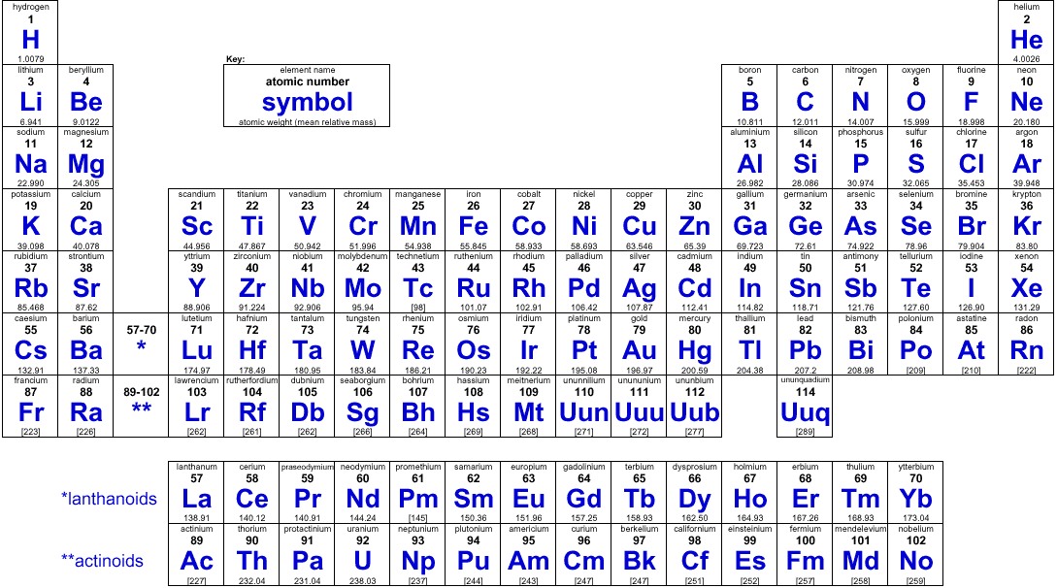



**Periodic**



# Table “A”







**Periodic**



## Table “B”





**Periodic**



**Table “C”**

