Molecules Worksheet

For each of the following molecules, identify the kind of atoms and the number of each. The first one is done for you.



|  |  |
| --- | --- |
| **Chemical Formula** | **Kinds and Number of Atoms in Each Molecule** |
| Ex. CaCO3 | 1 atom calcium, 1 atom carbon, 3 atoms oxygen |
| AgBr |  |
| PbS2 |  |
| MgCl2 |  |
| Al2O3 |  |
| PbCl4 |  |
| Fe2O3 |  |
| AlP |  |
| NH4OH |  |
| NaHSO4 |  |
| PbSO3 |  |



Each particle of the following contains the atoms listed. Write the formula of each compound. The first one is done for you.

|  |  |
| --- | --- |
| 1. One copper atom and one sulphur atom 2. One nitrogen and three hydrogen atoms 3. Two hydrogen and one sulphur atom 4. One hydrogen, one nitrogen and three oxygen atoms 5. Two potassium, one carbon and three oxygen atoms 6. Two aluminium and three oxygen atoms 7. One iron, one phosphorus and four oxygen atoms 8. One nitrogen, four hydrogen, one carbon and three oxygen atoms 9. One potassium, one chlorine and three oxygen atoms 10. Six carbons, twelve hydrogen and 6 oxygen atoms 11. One carbon, three hydrogen, one oxygen and one hydrogen | CuS  _________ _________ _________ _________  _________ _________ _________  _________ _________ _________ |

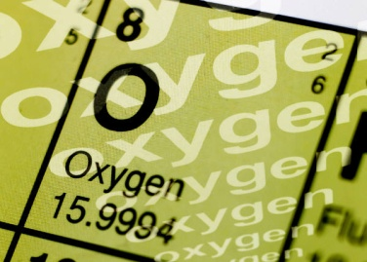Symbols for Elements

The left-hand column in the chart below contains statements about various elements. Write the name and symbol for the element each statement refers to. If you need help, use the periodic table on page 54 of *BC Science 9*

*.*

