Protons, Neutrons, and Electrons for ATOMS!!!
Fill in the blanks

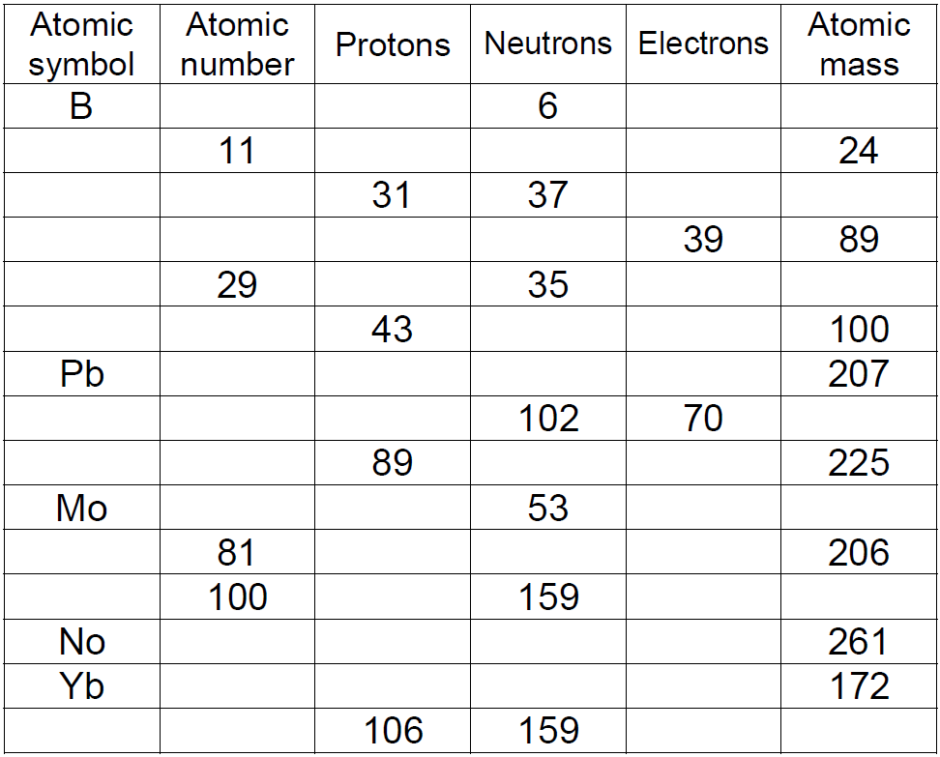
MASS #
(Atomic Mass rounded off)
173
39

ANSWER KEY

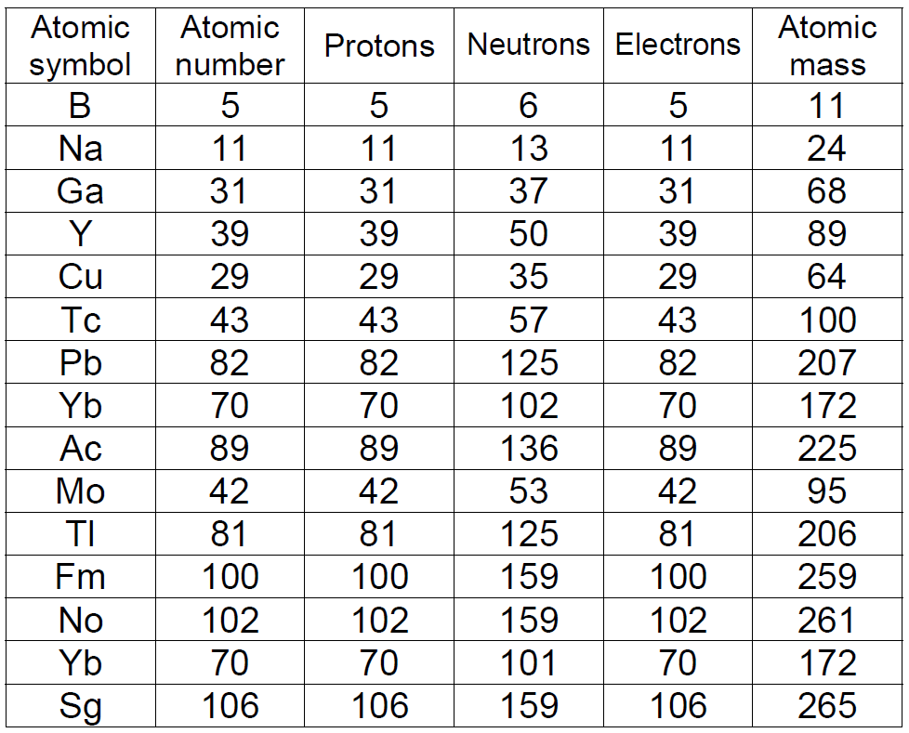
MASS #
(Atomic Mass rounded off)
173
173
103
103
70
39

