Static Electricity: Induction



**Draw** what will happen to the positive and negative particles in the following diagrams:



a. Neutrally charged Glass Positively Charged object Attract or Repel



brought near...



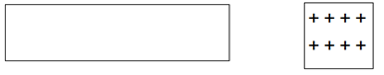



b. Neutrally charged Plastic strip Negatively charged object Attract or Repel



brought near...



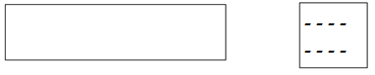



c. Wood is rubbed with wool: Positively charged object Attract or Repel



brought near...







d. Rubber balloon is rubbed with Negatively charged object Attract or Repel



human hair: brought near...



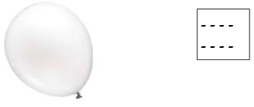



e. Rubber balloon is rubbed with Neutral object Attract or Repel



human hair: brought near...

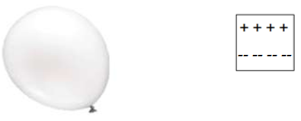



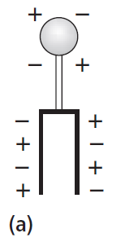Static Electricity: Conduction

1. Complete the diagrams below to show how the leaves of a neutral electroscope shown in (a) would respond when:

(b) a positive rod is brought near

(c) a positive rod touches the metal ball of the electroscope

(d) the rod is removed

(e) the metal ball is touched by a human finger

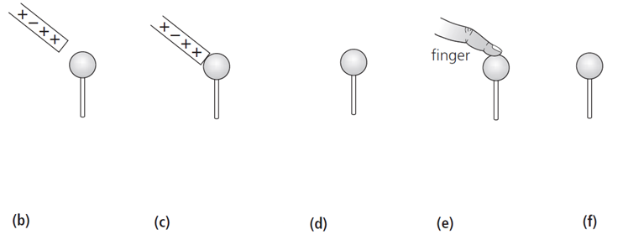(f ) the metal ball is left untouched. Show the charges.



2. A negatively charged vinyl rod is brought near and touches the pith ball (**a**). Draw what will happen to the positive and negative particles in **b**. Draw in **c**. if they attract or repel?

