Practicing Calculating Ohm’s Law
1. An automobile headlight has an average resistance of 24 Ω. Car batteries provide a potential difference of 12 V. What amount of current passes through the headlight? (I = 0.48 A) | 2. In a portable radio, 0.50 A of current are flowing through a conductor that provides 18 Ω of resistance. What potential difference is provided by the battery? (9.0 V)
3. A clothes dryer uses a 220 V power source. The coils of the heater provide an average resistance of 12 Ω. What amount of current is flowing through the heating coils? (18.3 A) | 4. An automobile headlight has a resistance of 40Ω when attached to a standard 12 V battery. How much current flows through the headlight? (0.30 A)
5. Only 2.5 × 10⁻³ A of current pass through a portable CD player. If the CD player is operated by a 9.0 V battery, what is the resistance within the circuit? 3600 Ω | 6. A 9.0 V battery maintains a current of 3.0 A through a portable radio. What is the resistance of the conductor? 3.0 Ω
7. What is the resistance of a hair dryer plugged into a 110 V outlet with a 10 A current flowing through it? 11 Ω | 8. A light bulb will allow 0.50 A to flow through it. If the outlet provides a potential difference of 110 V, how much resistance is provided by the bulb? 220 Ω
9. A portable CD player, operating with four 1.5 V batteries connected in series, provides a resistance of 15 000 Ω. What amount of current is flowing through the CD player? (0.0004 A) | 10. An electric motor has an operating resistance of 25 Ω when a 4.8 A current is flowing through it. What is the potential difference of the outlet the motor is plugged into? (120 V)
11, What is the current reading in the ammeter in this circuit?  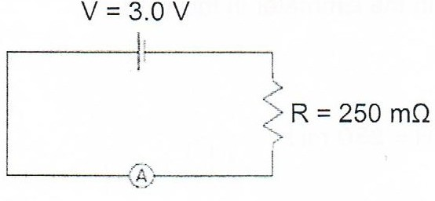 | 12. Draw a circuit that has two 1.5 V batteries in series, a 0.5 Ω resistor, a switch and an ammeter.  What is the current reading in the ammeter?

