PERIODIC TABLE ASSIGNMENT
STEP 1: Your first task is to label and color code the items listed below on the periodic table of elements. Each of the items should be clearly labelled and coloured in a different colour. You may want include a legend on your periodic table in order to achieve this task.

- Dividing line between the Metals, Non-metals & Metalloids
Must include Element:
- Name
- Symbol
- Atomic #
- Charge
- In a LEGEND, label the 5 Families
(Outline them in different colours)
- A Family of One - Hydrogen
- Alkali Metals
- Alkaline Earth Metals
- Halogens
- Noble Gases

EVALUATION:
- This assignment is out of 20 marks
- It will be evaluated by one of your peers.
- The evaluation will be based on the set of criteria listed on the back of this sheet.
- They will be given time to complete this peer-evaluation of your assignment at the beginning of next class.

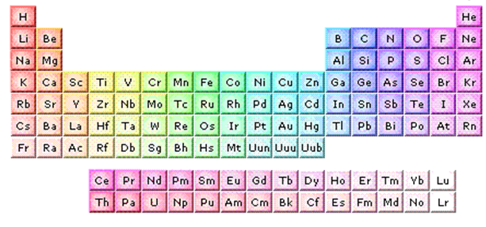

DUE DATE: __________________________________________
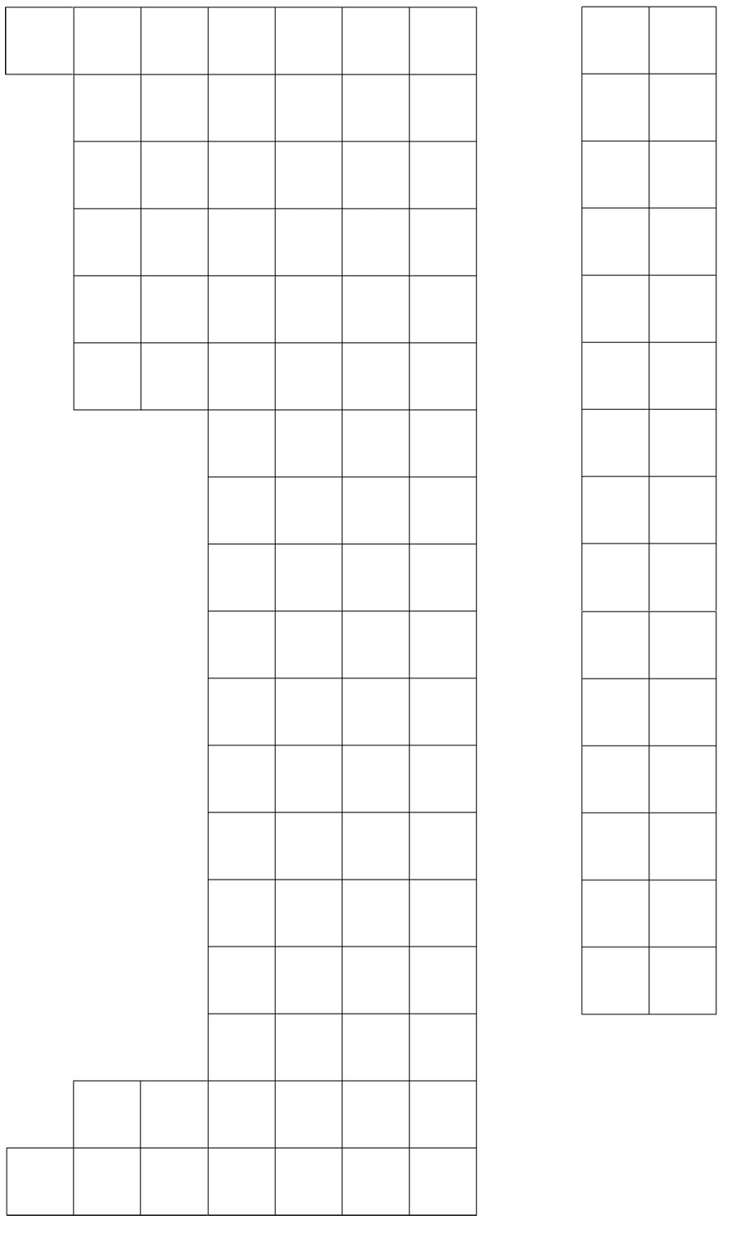

THE PERIODIC TABLE PEER EVALUATION KEY

NAME OF STUDENT:_________________________ NAME OF MARKER:____________________

CONTENT MARK | PEER EVALUATION | TEACHER EVALUTION
Full name, date, & block in top right corner (1)

LABELLING & COLORING (14 marks)
Dividing line between Metals, Non-metals & Metalloids (2)

Legend colour coding the 5 families: (1)
1. A Family of One – Hydrogen (1)
2. Alkali Metals (1)
3. Alkaline Earth Metals (1)
4. Halogens (1)

5. Noble Gases (1)

Element Information (6)
PRIDE MARK (5 marks)
1. Neat (2)
(Is the periodic table in good condition? Are the labels clearly written? Are the labels neatly written? Is the periodic table coloured neatly?)
- Colourful and Eye-catching (3)
(Is the periodic table visually appealing? Is each item on it coloured in a different colour? Is the colouring dark and vibrant or dull and sketchy?)
TOTAL (20)

COMMENT:
This student received a mark of /20 because……. ___________________________________
__________________________________________________________________________________________________________________________________________________________

