C:\Users\Nindi\AppData\Local\Microsoft\Windows\Temporary Internet Files\Content.IE5\EJRV5VSP\MC900130271[2].wmfAssignment #5: Multiplying & Dividing Polynomials /27

|  |  |
| --- | --- |
| ../../../art/chapter%207/jpg/BLM7-7-1.jpg = positive 1 | BLM7-5-4../../../art/chapter%207/jpg/BLM7-7-2.jpg = negative 1 = positive xy-tile |
| BLM7-7-3 = positive *x* | ../../../art/chapter%207/jpg/BLM7-7-4.jpg = negative *x* |
| BLM7-7-5  = positive *x*2 | ../../../art/chapter%207/jpg/BLM7-9-5.jpgBLM7-9-8 = positive y-tile  = negative *x*2 |

1. Sergio wanted to determine 5*x*(7*x* – 2). His solution is shown below. *(2 marks)*

(5*x*)(7*x*) + (5*x*)(–2) Step 1

= (5)(7)(*x*)(*x*) + (5)(–2)(*x*)(–2) Step 2

= 35*x*2 – 10(–2*x*) Step 3

= *x* 35*x*2+ 20*x* Step 4

Sergio discovered an error in his solution.

In which step did Sergio make the error? Show the correct solution.

2. Use an area model to expand each expression. *(2 marks)*

a) (3*x*)(2*x* – 1) b) (4*d* + 3)(3*d*)

3. Determine the polynomial multiplication statement shown by the diagrams and SOLVE.

*(4 marks)*

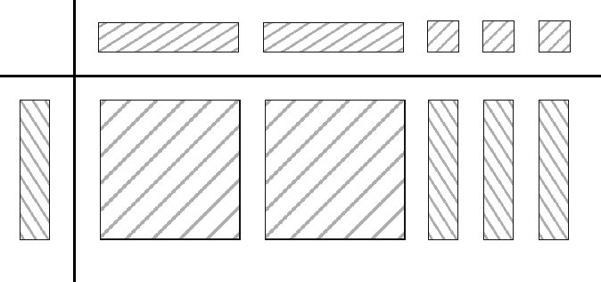a) b)

4.Complete the following statements: *(3 marks)*

 a) The product (–3.7*x*)(5.1*y*), in simplified form, is ____.

 b) The quotient 10*x*2÷ 4*x*, in simplified decimal form, is ____.

 c) Multiplying the polynomial *x* – 6 by 5*x* produces the expression ____.

5. Use the distributive property to expand each expression. *(2 marks)*

a) (5*m*)(2*m* + 3) b) (–*n*)(*n* + 1)

6. Multiply. *(4 marks)*

a) (4*m* + 1)(3*m*) b) (2*x* – 3)(–4*x*)

c) (4.2*n*)(2*n* – 7) d) 

7. Use algebra tiles to divide each of the following expressions and SOLVE. *(4 marks)*

a)  b) 

8. Divide. *(6 marks)*

a)  b) 

c)  d) 

e)  f) 