Biology Review
- gene  - chromosome  - DNA  - enzyme  - photosynthesis  - nucleus  - mitochondria  - ribosome  - cytoplasm  - selectively permeable  - bacteria  - virus  - sexual reproduction  - asexual reproduction  - meiosis  - gamete  - zygote  - mitosis  - fertilization  - cancer  - diploid  - haploid  - cytokinesis  - hereditary  - genetics  - trait | ____  ____  ____  ____  ____  ____  ____  ____  ____  ____  ____  ____  ____  ____  ____  ____  ____  ____  ____  ____  ____  ____  ____  ____ | Smallest and simplest form of life (single cell without nucleus)  The “powerhouse” of cell  Allows some molecules to pass through but not others  Control center of the cell  Lack most of the characteristics of living things  Protein that speeds up a chemical reaction  Material in which nucleus and organelles are suspended  Section of DNA molecule that codes for a specific enzyme  Takes place in chloroplasts  Protein factory of the cell  Molecule that contains genetic instructions for the cell  A structure in the nucleus that contains genes  Combining of a male and female reproductive cell  New cell that results from the fertilization of an egg  Having pairs of homologous chromosomes  Special cell for reproduction  Separation of paired chromatids into two identical sets  Process producing specialized reproductive cells  A group of cells that don’t reproduce properly  Having only one chromosome of each type  Process in which cytoplasm divides into 2 roughly equal halves  Production of offspring from a single parent  Reproduction that requires two parents  The study of heredity  Having different alleles for a particular gene  Passing on of characteristics from parents to offspring

- The three main functions of cell division are __________________, ______________, ____________

- For each of the following parts, describe location and function:
Structure | Location | Function
Nuclear membrane
Chromosomes
Nucleolus
ribosomes
Endoplasmic Reticulum (ER)
Centrioles

- What are the 4 bases that make up DNA: _________________________________ ___________________________. What are the 3 parts of DNA: ______________ ___________________________________.

- List the 6 parts of the cell cycle in order: _________________________________ _________________________________________________________________

- What 2 things happen during interphase: __________________________________
- Label the stages of Mitosis below.
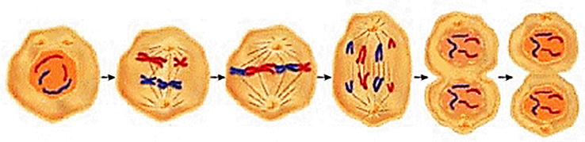
________________ ________________ _____________ _______________ ____________ _________

- How is cytokinesis different in plants and animals? ___________________________ _________________________________________________________________

- What is the main difference between asexual and sexual reproduction? ___________ _________________________________________________________________
- For each method of asexual reproduction, define and give an example.
Method | Definition | Example
Binary
Fission
Budding
Vegetative
Reproduction
Fragmentation
Spore
Formation
- A cell that is _______________ contains the normal number of chromosomes. These cells are sometimes referred to as ____________ or body cells. In humans there are _____ chromosomes in one of these cells. A cell that is _____________ contains _____________ the normal number of chromosomes. These cells are sometimes referred to as ______________ or sex cells. In humans, there are ____ chromosomes in one of these cells.

- Meiosis consists of _____ phases: ________________ and _________________.

- At the end of the 1st phase, the __________________ ___________________ have been separated. At the end of the 2nd phase, the _________________ _______________ have been separated. The result of meiosis is ____ cells with ______ the normal number of chromosomes.

- The advantage of sexual reproduction is that it increases the _______________ among organisms.

- Copy Table 1 (p. 81)
Feature | Asexual Reproduction | Sexual Reproduction
# of parents
# of offspring
Variety of offspring
Speed of reproduction
Timing

- For each method of sexual reproduction, define and give an example.
Method | Definition | Example
Conjugation

Hermaphrodites
Flowering Plants

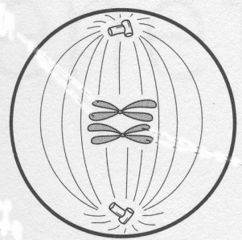
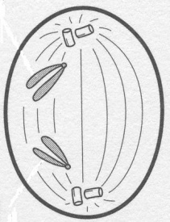
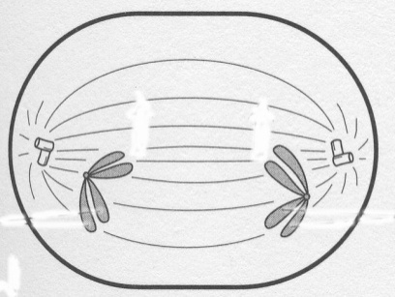
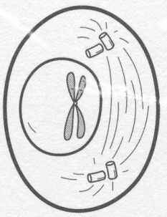
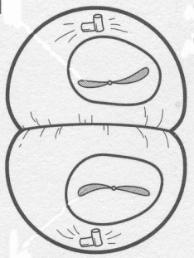
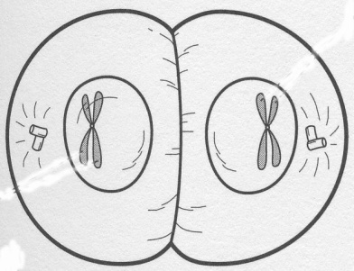
- Label the stage of Meiosis that is occurring. Be specific. NOTE: diagrams are not in order. (6)
___________________ ___________________ ___________________
___________________ _____________________ ____________________
- Number the steps in the correct order of Meiosis. (5)
____ homologous chromosomes pair up and line up in the middle of the cell
____ chromosomes thicken and coil up
____ cell divides into 2 cells
____ 4 haploid cells are formed
____ chromatids separate and move to ends of cell

- Meiosis or Mitosis? Fill in the blank. (5)
_____________ Produces 4 daughter cells.
_____________ Division that produces egg and sperm cells
_____________ Produces cells with the same number of chromosomes as the original cell
_____________ Produces cells that are clones of the original cell
_____________ Produces cells with half the number of chromosomes as the original cell

