C:\Documents and Settings\gill_narinder\Local Settings\Temporary Internet Files\Content.IE5\79YQ0BIL\MC900231014[1].wmfPhysics Review

Static charge is \_\_\_\_\_\_\_\_\_\_\_\_\_\_\_\_\_\_\_\_\_\_\_\_\_\_\_\_\_\_\_\_\_\_\_\_\_\_\_\_\_\_\_\_\_\_\_\_\_\_\_\_\_\_\_\_\_\_\_\_\_\_

|  |  |
| --- | --- |
| FRICTION |  |
| CONDUCTION |  |
| INDUCTION |  |

Electric force is \_\_\_\_\_\_\_\_\_\_\_\_\_\_\_\_\_\_\_\_\_\_\_\_\_\_\_\_\_\_\_\_\_\_\_\_\_\_\_\_\_\_\_\_\_\_\_\_\_\_\_\_\_\_\_\_\_\_\_\_\_\_\_\_\_\_\_\_\_\_\_\_\_\_\_\_

Law of Static Charge: \_\_\_\_\_\_\_\_\_\_\_\_\_\_\_\_\_\_\_\_\_\_\_\_\_\_\_\_\_\_\_\_\_\_\_\_\_\_\_\_\_\_\_\_\_\_\_\_\_\_\_\_\_\_\_\_\_\_\_\_\_\_\_\_\_\_\_\_\_\_

* An amber rod develops a \_\_\_\_\_\_\_\_\_\_\_\_\_\_\_\_\_ charge when rubbed with wool or fur.
* A plastic rod develops a \_\_\_\_\_\_\_\_\_\_\_\_\_\_\_\_\_charge when rubbed with cotton

If human hair is rubbed with a rubber balloon:

a. Electrons will be transferred from the \_\_\_\_\_\_\_\_\_\_\_\_\_\_\_\_\_\_\_\_ to the \_\_\_\_\_\_\_\_\_\_\_\_\_\_\_\_\_\_\_\_\_\_\_\_\_.

b. The \_\_\_\_\_\_\_\_\_\_\_\_\_\_\_\_\_\_\_\_\_\_ will become negatively charged.

c. The \_\_\_\_\_\_\_\_\_\_\_\_\_\_\_\_\_\_\_\_\_\_ will become positively charged.

If wood is rubbed with cotton:

a. Electrons will be transferred from the \_\_\_\_\_\_\_\_\_\_\_\_\_\_\_\_\_\_\_\_ to the \_\_\_\_\_\_\_\_\_\_\_\_\_\_\_\_\_\_\_\_\_\_\_\_.

b. The \_\_\_\_\_\_\_\_\_\_\_\_\_\_\_\_\_\_\_\_\_\_\_ will become negatively charged.

c. The \_\_\_\_\_\_\_\_\_\_\_\_\_\_\_\_\_\_\_\_\_\_\_ will become positively charged.

**OHM’s Law**

|  |  |  |
| --- | --- | --- |
| Symbol | Represents | Units |
| I |  |  |
| Q |  |  |
| t |  |  |

|  |  |  |
| --- | --- | --- |
| Symbol | Represents | Units |
| V |  |  |
| I |  |  |
| R |  |  |

|  |  |
| --- | --- |
| 1. A current of 24 mA is equivalent to how many Amperes? (0.024 A) | 2. If the current in a wire is measured to be 12 A, how much charge passes by a point in the circuit every minute? (720 C) |
| 3. What is the current in a wire if 25 x 10-3 C of charge passes by a point in 5 seconds? (0.005 A) | 001 - Copy (2).jpg4. What is the current reading in the ammeter in this circuit? (12 A) |

**SERIES & PARALLEL**

|  |  |  |
| --- | --- | --- |
| **Type of Circuit** | **Series** | **Parallel** |
| Total Current (IT) |  |  |
| Total Voltage (VT) |  |  |
| Total Resistance (RT) |  |  |

5. **Current** (units = \_\_\_\_\_\_\_\_\_\_\_\_\_\_\_\_ = \_\_\_\_\_\_\_\_)

Series: IT = \_\_\_\_\_\_\_\_\_\_\_\_\_\_\_\_ Parallel: IT = \_\_\_\_\_\_\_\_\_\_\_\_\_\_\_\_

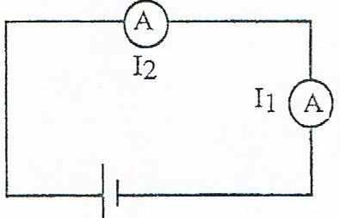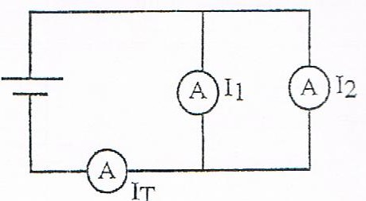

6. **Voltage** (units = \_\_\_\_\_\_\_\_\_\_\_\_\_\_\_\_ = \_\_\_\_\_\_\_\_)

Series: VT = \_\_\_\_\_\_\_\_\_\_\_\_\_\_\_\_ Parallel: VT = \_\_\_\_\_\_\_\_\_\_\_\_\_\_\_\_

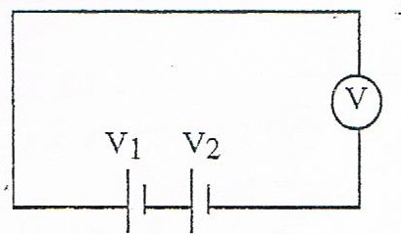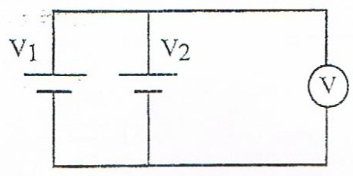

7. **Resistance** (units = \_\_\_\_\_\_\_\_\_\_\_\_\_\_\_\_ = \_\_\_\_\_\_\_\_)

Series: RT = \_\_\_\_\_\_\_\_\_\_\_\_\_\_\_\_ Parallel: 1 = \_\_\_\_\_\_\_\_\_\_\_\_\_\_\_\_\_\_\_\_\_\_\_

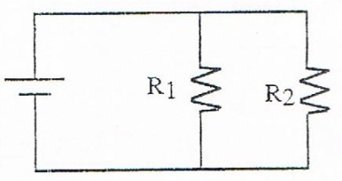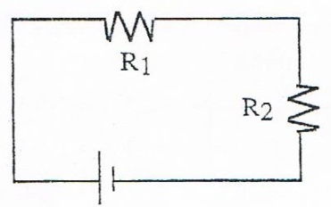RT

Draw Circuit Diagrams:

|  |  |
| --- | --- |
| 8. A series circuit consisting of:   * 12 V electrical source * open switch * two light bulbs * 10 Ω resistor | 9. A parallel circuit consisting of:   * 9.0 V electrical source * open switch * three 5.0 Ω resistor |
| 10. A circuit consisting of:   * three 1.5 V cells connected in parallel * open switch * two light bulbs connected in series * two 15 Ω resistor connected in parallel | 11. Draw a circuit diagram consisting of a 9.0 V battery, an ammeter, and a 25 Ω resistor in series. Include a voltmeter that is measuring the potential difference across the resistor. |
| 12. Draw a circuit diagram consisting of a battery made up of two 1.5 V cells, one closed switch, two lamps, and an ammeter in series. Show the direction in which the current flows. | 13. Draw a circuit diagram consisting of a battery made up of four 1.5 V cells, one closed switch, one lamp, two 0.50 Ω resistors in series, and a voltmeter. Show the direction in which the current flows. |

14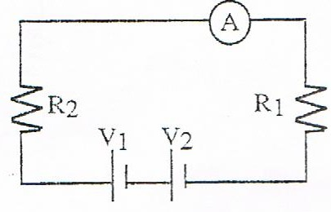. Find: VT = \_\_\_\_\_\_\_\_\_ V1 = 1.5 V

RT = \_\_\_\_\_\_\_\_\_ V2 = 1.5 V

IT = \_\_\_\_\_\_\_\_\_

R1 = 7 Ω

R2 = 3 Ω

I1 = 300 mA

---------------------------------------------------------------------------------------------------------------------------------------

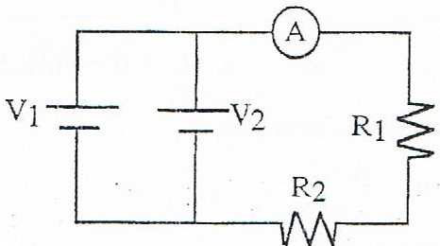15. Find: VT = \_\_\_\_\_\_\_\_\_ V1 = 3 V

RT = \_\_\_\_\_\_\_\_\_ V2 = 3 V

IT = \_\_\_\_\_\_\_\_\_

RT = 6 Ω

R2 = 4 Ω

I1 = 0.5 A

---------------------------------------------------------------------------------------------------------------------------------------

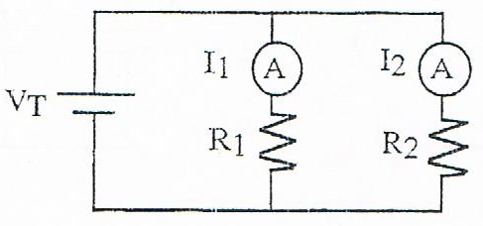16. Find: IT = \_\_\_\_\_\_\_\_\_ I1 = 0.6 A

RT = \_\_\_\_\_\_\_\_\_ I2 = 0.6 A

R1 = 15 Ω

R2 = 15 Ω

VT = 9 V

---------------------------------------------------------------------------------------------------------------------------------------

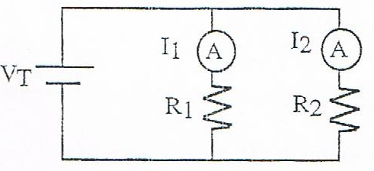17. Find: IT = \_\_\_\_\_\_\_\_\_ I1 = 0.3 A

R1 = \_\_\_\_\_\_\_\_\_ I2 = 0.3 A

R2 = 10 Ω

VT = 3 V

|  |  |
| --- | --- |
| 18. What is the resistance of a toaster if a current of 12.5 A flows through it when it is connected to 120 V? (9.6Ω) | 19. A light bulb has a resistance of 90  What current flows through the bulb when it is connected to 120 V? (1.3 A) |
| 20. A current of 0.50 A flows through a light bulb that has a resistance of 18 Ω. What is the voltage across this light bulb? (9.0 V) | 21. A flashlight bulb has a resistance of 4.0 Ω. What current passes through the bulb if it is connected to 3.0 V? (0.75 A) |

**POWER & ENERGY**

**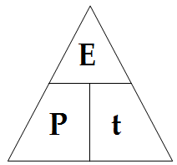**

**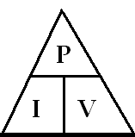**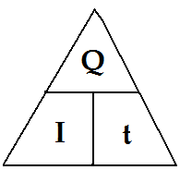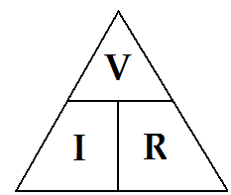

**E = P x t P = I x V V= I x R Q= I x t**

|  |  |  |
| --- | --- | --- |
| Symbol | Represents | Units |
| P |  |  |
| E |  |  |
| t |  |  |

|  |  |  |
| --- | --- | --- |
| Symbol | Represents | Units |
| P |  |  |
| I |  |  |
| V |  |  |

|  |  |
| --- | --- |
| 22. A portable hair dryer, plugged into a 110 V outlet, has a current of 10 A flowing through it. What is the power rating of the hair dryer? (1100 W) | 23. A current of 0.50 A flows through a light bulb connected to a 110 V outlet. How much power is “lost” by this bulb? (55 W) |
| 24. A toaster connected to a 110 V power source has 6.0 A of current flowing through it. How much power is dissipated as heat? (660 W) | 25. A light bulb draws 1.25 A of current from a 120 V gasoline-powered generator.  (a) How much power does the generator produce? (150W)  (b) If the generator runs for 5.0 min, how much energy will the lamp convert into heat and light?  (45 kJ or 4.5 × 104 J) |

|  |  |  |
| --- | --- | --- |
| 1. A microwave oven operates on 5 amps of current on a 110-volt circuit for one hour. Calculate the total **kilowatt-hours** used. (0.550 kW⋅h) | 1. How much would it **cost** to run the microwave in question #26 if the cost of energy is $0.10 per kWh? ($0.055) | |
| 1. A refrigerator operates on 15 amps of current on a 220-volt circuit for 18 hours per day. How many **kilowatt-hours** are used per day? (59.4 kW⋅h) | 1. If the electricity costs are $0.15 per kWh, how much does it **cost** to run the refrigerator in Problem 12 per day? ($8.91) | |
| 1. The meter reading on June 1 was 84502 kWh. On July 1, the meter read 87498 kWh. If the cost of electricity in the area was $0.12 per kWh, what was the **electric bill** for the month of June? ($359.52) | 1. A room was lighted with three 100-watt bulbs for 5 hours per day. If the cost of electricity was $0.09 per kWh, how much would be **saved** per day by switching to 60-watt bulbs? ($0.54) | |
| 32. A meter reader determines that a business has used 3550 kW⋅h of energy in two months. If electricity costs 10¢ per kW⋅h, calculate the bill. ($355.00) | 33. An electric heater draws 1100 W of power. Electricity costs 8¢ per kW⋅h. How much does it cost to operate the heater 3.0 h a day for 30 days? ($7.92) |
| 34. A 730 W toaster and 1200 W electric frying pan are plugged into the same 100 V outlet. How much will it cost to operate the two appliances at 8¢ per kW⋅h if they are used for 20 h? ($3.09) | 35. A toaster is used an average of 5.0 h a month. The toaster draws 8.0 A of current from a 110 V outlet. If electricity costs 8¢ per kW⋅h, how much will it cost to operate the toaster for one year? ($4.22) |

36. On December 1, the electric meter read 75 224 kWh. On January 1, the meter read 76 920 kWh. The cost of electrical energy is $0.28/kWh.

|  |  |
| --- | --- |
| 1. Calculate the energy consumed during the month of December. (1696 kW⋅h) | 1. What did the electricity cost for the month? ($474.88) |

37.



38. The dials below show the electric meter of a small business during the month of February.

(a) How much electrical energy was used during the month? (8821 kW⋅h)

(b) If electrical energy costs $0.0691/kW·h, what was the electric bill for the month? ($609.53)