ASSIGNMENT #6 Surface Area /20

Find the Surface area of the following:

a)

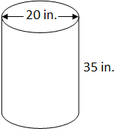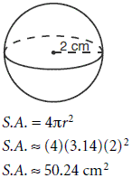

b)

c)

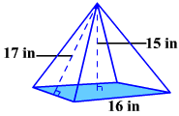

d)

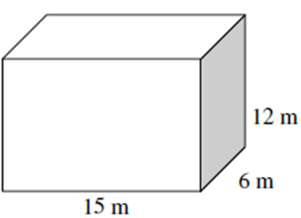

e)

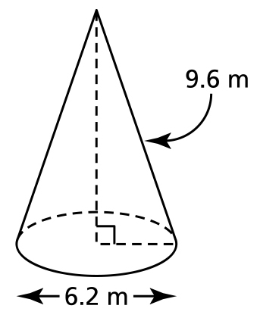

f)



g)



h)



i)



j) Jim is making a toy box. The box is 24 in. long, 18 in. deep and 36 in. tall. Calculate the surface area of the toy box in square inches.