Atomic Molecular Theory.
I know the three subatomic particles, their location within the atom, and forces that bind them to the atom
I can determine the number of protons, neutrons, and electrons of an atom using the periodic table
I can draw a Bohr Model of an atom (elements 1-20)

Atomic Theory

1. An atom is the smallest particle of an element that has the properties of that element.

2. An element is a pure substance that cannot be chemically broken down into simpler substances.
Example: Oxygen (O) is an element.

3. A compound is a pure substance that is made up of two or more different elements that have been combined in a specific way.
Example: H₂O is a compound made of the elements hydrogen and oxygen.

4. An atom includes smaller particles called protons, neutrons, and electrons**
• Protons are subatomic particles that have a 1+ (positive) charge.
• Neutrons are subatomic particles that do not have an electric charge.
• Electrons are subatomic particles that have a 1− (negative) electric charge.

**These subatomic particles are made up of elementary particles. Refer to the Thinking beyond section.

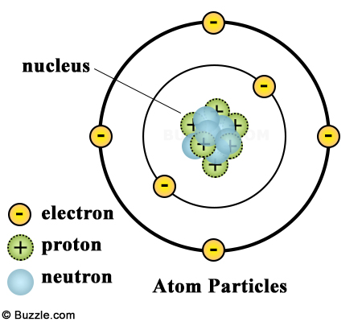
The Nucleus

1. The nucleus is at the centre of an atom
• The nucleus is composed of protons and neutrons.
• Electrons exist in the area surrounding the nucleus.

2. The number of protons = the number of electrons in every atom

3. The nuclear charge = the electric charge on the nucleus = the number of protons

4. The atomic number = the number of protons = the number of electrons
Thinking Beyond: _____________________________________________________
Quarks and Leptons (Elementary Particles)

What is an elementary particle?

An elementary particle is a particle that is not made up of any smaller particles. Elementary particles are the building blocks of the universe. All the other particles and matter in the universe are made up of elementary particles.

Types of Elementary particles

We won't go into a lot of detail on these particles, but it is interesting to know the names of some of these particles and how they make up larger particles such as the proton and neutron.

There are two main categories of elementary particles: fermions and bosons.

Fermions

Fermions are the matter particles. All matter is made up fermions. Fermions are divided into two types of particles: quarks and leptons.
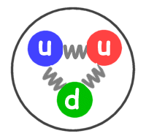
Quarks - Quarks are the basic building blocks for protons and neutrons. There are six types of quarks and they have pretty interesting names including up, down, charm, strange, top, and bottom. The different types of quarks are called "flavors" by physicists.

Leptons - One type of lepton that you have probably heard of is the electron. Electrons are important building blocks for atoms. A proton is made up of three quarks

