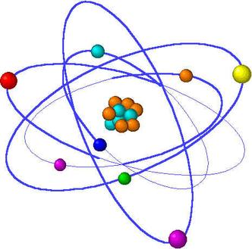
Bohr Models for ATOMS
1. Label the following diagram of an atom from the periodic table. Use the following labels:
Atomic mass, symbol, atomic number, atomic name

8
O
Oxygen

15.9

2. Fill in the blanks with the values for the following ATOMS
11
Na
Sodium

23.001
7
N
Nitrogen

14.007
9
F
Florine

18.9

# of P⁺ :_____________ # of P⁺ :_____________ # of P⁺ :_____________
# of Nº :_____________ # of Nº :_____________ # of Nº :_____________
# of E⁻ :_____________ # of E⁻ :_____________ # of E⁻ :_____________

8
O
Oxygen

16.0
6
C
Carbon

12.2
1
H
Hydrogen

1.0001

# of P⁺ :_____________ # of P⁺ :_____________ # of P⁺ :_____________
# of Nº :_____________ # of Nº :_____________ # of Nº :_____________
# of E⁻ :_____________ # of E⁻ :_____________ # of E⁻ :_____________

14
Si
Silicon

28.1
19
K
Potassium

39.1

# of P⁺ :_____________ # of P⁺ :_____________

# of Nº :_____________ # of Nº :_____________
# of E⁻ :_____________ ` # of E⁻ :_____________

