Invertebrate Review Package: Part I
26-1: Introduction to the Animal Kingdom
1. The seven essential life functions of an animal are listed below. Each of the statements that follow refers to one of these functions. In the blank before each statement, write the life function to which the statement refers. You may use some functions more than once.
feeding, excretion, respiration, response , movement, internal transport, reproduction

_________ a. A pumping organ called a heart forces a fluid called blood through a
series of blood vessels.
b. In some species, eggs hatch into larvae, which later undergo a
process called metamorphosis.
c. Sense organs, such as eyes and ears, gather information from the
environment.
d. Some animals are carnivores, whereas others are herbivores.
e. Harmful wastes from cellular metabolism must be eliminated.
__________f. The combination of an animal's muscles and skeleton is called its musculoskeletal system.
__________g. Some species of animals bear their young alive, whereas others lay eggs.
__________ h. The cells of an animal must consume oxygen and give off carbon
dioxide.

26-2: Sponges
- Label the diagram of a sponge.
osculum, collar cell/choanocyte, pore cell, spicule, amebocytes/archaeocytes, epidermal cell, pore, central cavity

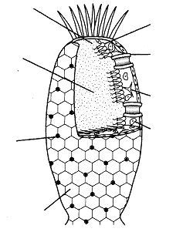
2. In the space provided, write the term that best matches each of the following definitions.
Amebocytes/archaeocytes, central cavity, collar cell/choanocytes, epidermal cell, pore, pore cell, spicule, osculum

________ a. The area enclosed by the body wall of the sponge amebocyte
________ b. A special kind of cell that builds
________ c. Cells that have flagella and trap food particles.
________ d. One of thousands of openings in the body wall
________ e. Large hole where water leaves the sponge
________ f. One of many structures that form the skeleton of the sponge
________ g. Specialized cell through which water enters the sponge
________ h. Cell on the outer surface of the sponge

3. Explain in one or two sentences how sponges carry out each of the following life functions.
Feeding: ______________________________________________________________
____________________________________________________________________
____________________________________________________________________
Internal Transport: _____________________________________________________
____________________________________________________________________
Excretion: ____________________________________________________________
____________________________________________________________________
Respiration: __________________________________________________________
____________________________________________________________________
Reproduction: ____________________________________________________________
____________________________________________________________________
____________________________________________________________________
____________________________________________________________________

25-3: Cnidarains
1. Most cnidarians have life cycles that involve two different body forms. Label each diagram below with the name of the correct body form. Then label both diagrams to show the following parts: epidermis, mesoglea, gastroderm, mouth, gastrovascular cavity, tentacle
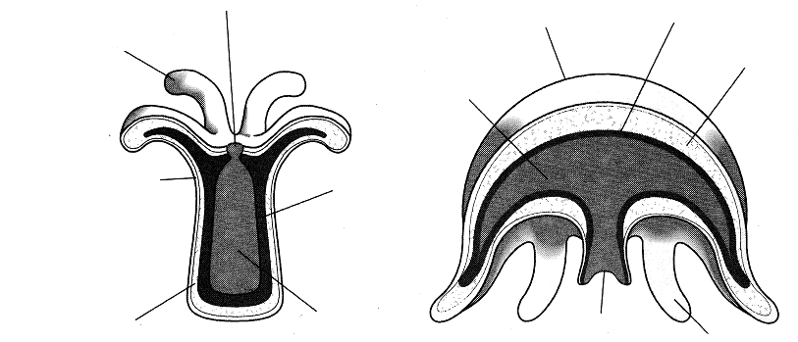

polyp medusa

2. Use the diagrams below to answer the questions that follow.

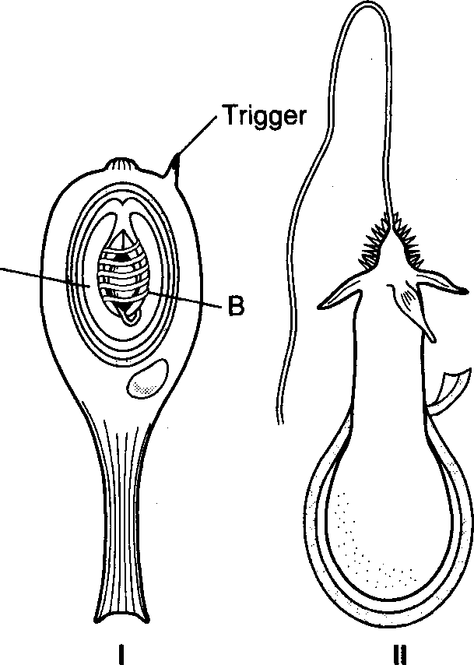
a. Where on the body of a cnidarian are these structures located? _____________________________________________
b. What occupies the region labeled A on the diagram? _______
c. What is the structure labeled B? _______________________
d. Briefly describe the condition of the stinging cell in Figure I. ________________________________________________
________________________________________________
e. What is the function of the trigger? ___________________
________________________________________________
f. What is the condition of the nematocyst in Figure II? What has happened? _________________________________________
________________________________________________
_________________________________________________
26-4 Unsegmented Worms
1. Each of the statements below describes either flatworms, roundworms, or both. If the statement describes flatworms, write an F in the blank before the statement. If the statement describes roundworms, write an R. If the statement describes both, write both an F and an R.
__________ a. Are invertebrates
__________ b. Are members of phylum Nematoda
__________ c. Includes blood flukes
__________ d. Includes free-living and parasitic animals
__________ e. Have a digestive system with only one opening
__________ f. May have asexual reproduction
__________ g. Eliminate undigested wastes through the anus
__________ h. Includes Ascaris

2. The body plan of a free-living flatworm is shown at right.
a. Label each structure on the diagram.
brain, pharynx, mouth, nerve cord, gastrovascular cavity, eyespot
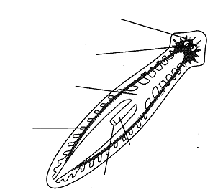
c. What type of symmetry does the body show? _______________________________
d. What is the purpose of the branches on structure A? ________________________
______________________________________________________________________
e. What evidence does this diagram show of cephalization? ________________________
_____________________________________________________________________
f. What is the function of the structure labeled D? _______________________________
______________________________________________________________________
g. What is the function of the structure labeled F? _______________________________
______________________________________________________________________

