Organization of the Periodic Table

1. The periodic table organizes all known elements in order by atomic number.

2. Rows of elements (across) are called periods.

3. Columns of elements (down) are called chemical families or groups.
• All elements in a family have similar properties and bond with other elements in similar ways.
Group 1 = alkali metals
Group 2 = alkaline earth metals
Group 17 = halogens
Group 18 = noble gases

4. Metals are on the left side of the table, non-metals are on the right side, and the metalloids form a “staircase” toward the right side.
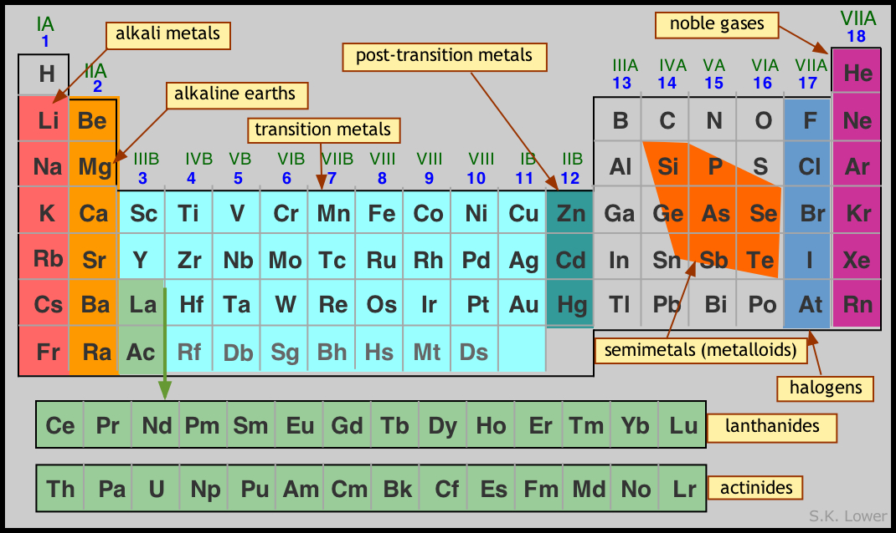

Quick Check # 2
1. What is the difference between a chemical family and a period in the periodic table?
________________________________________________________________________________________________________________________________________________________________
2. List the name and group number of four families of elements.
___________________________________ ___________________________________
___________________________________ ___________________________________

